Digital Image Processing – Project Report

Ammar Ahmed (023-19-0107), Section A

Instructor: Dr. Ghulam Murtaza Memon

**Task 1: Interpolation**

Following is the initial interface of Interpolation tab. There are 4 interpolation operations the user can perform, let us go through each of them along with the demonstration of the output.

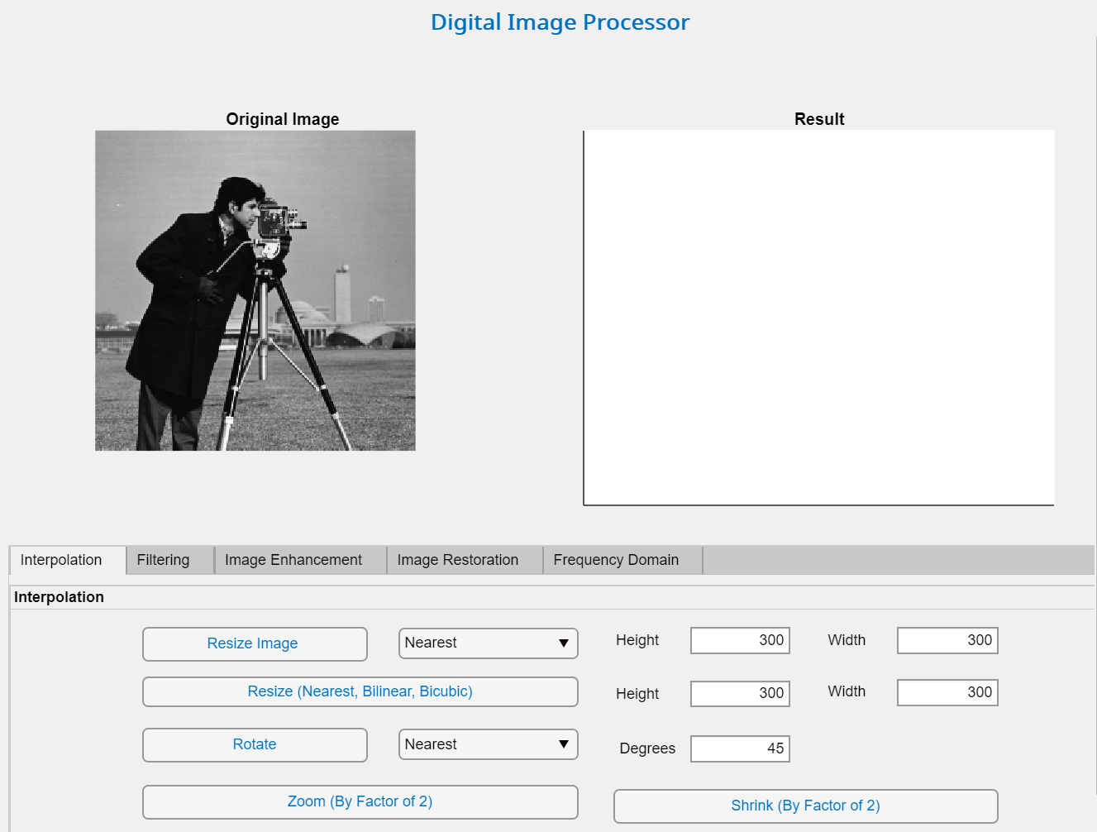

**Resizing:**

You can resize an image by specifying the height and the width of the image:



You can also specify the method of interpolation:

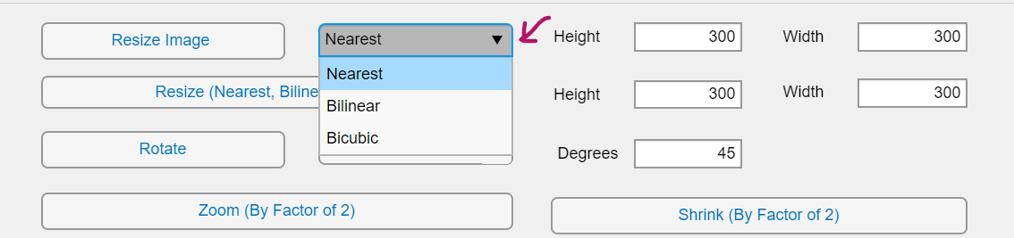

Output:

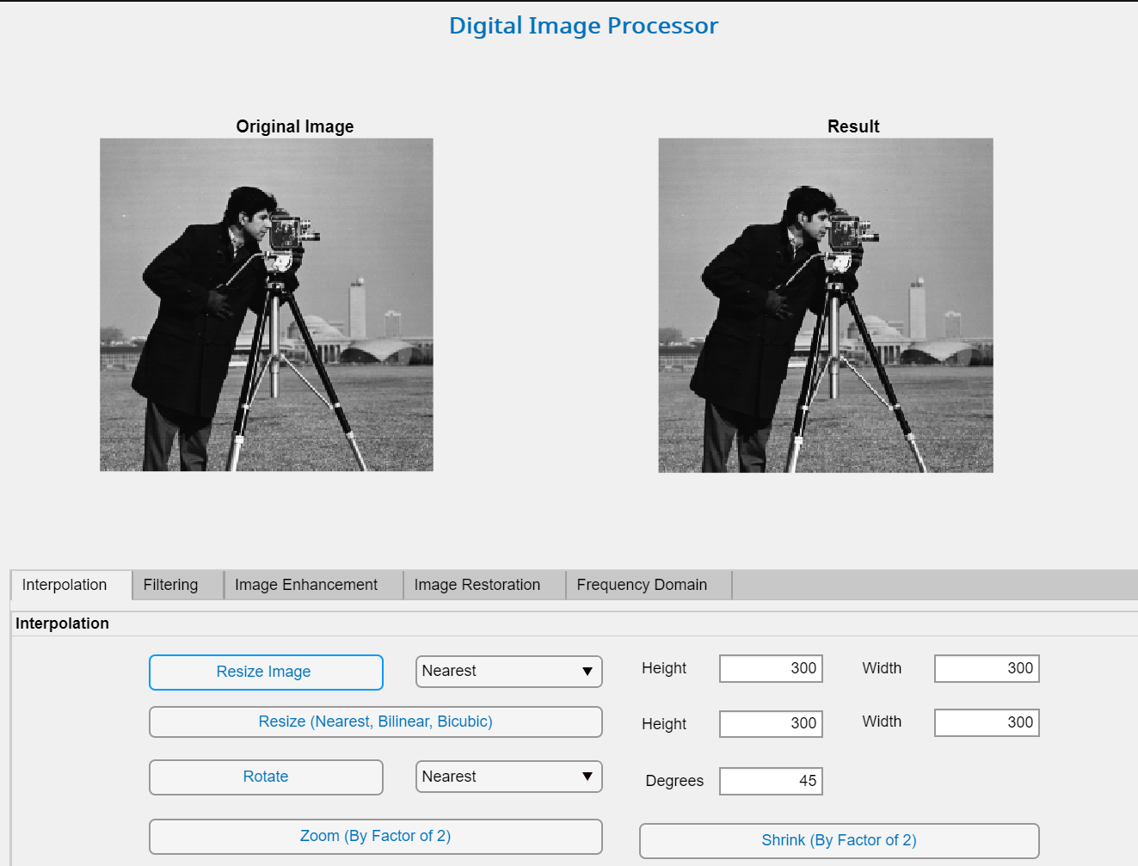

The user can also see the results of all methods (nearest, bilinear, bicubic) at once by clicking the following button.



Output:

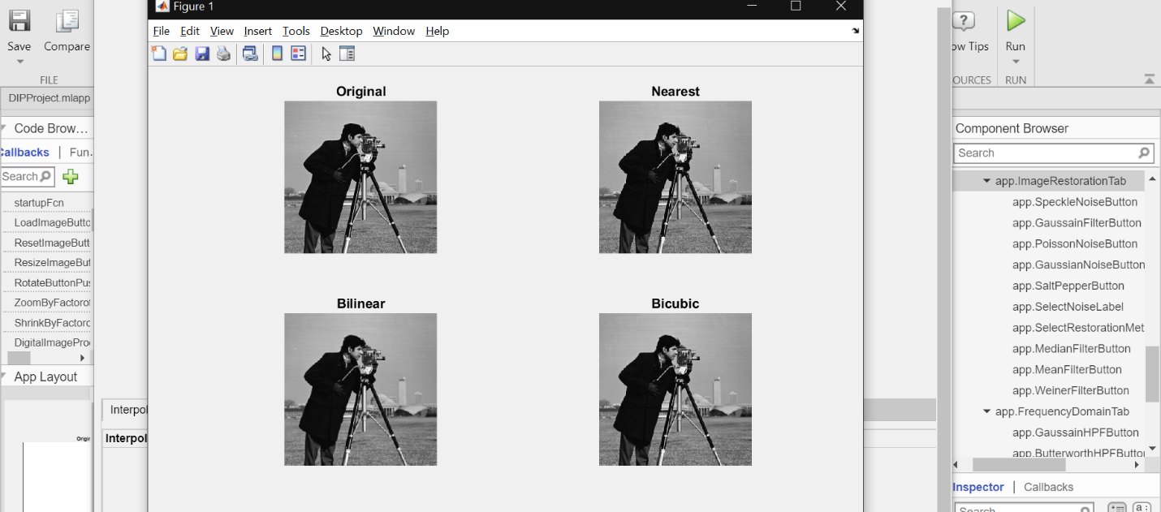

Code:

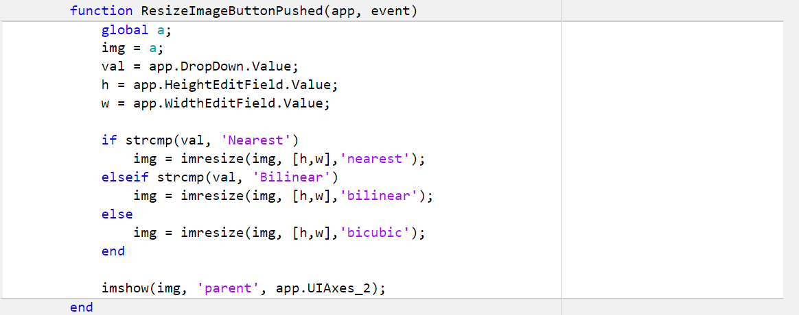

**Rotation:**

The user can also perform rotation under the interpolation tab. The user has the option of specifying the method of interpolation as well as the degrees of rotation.



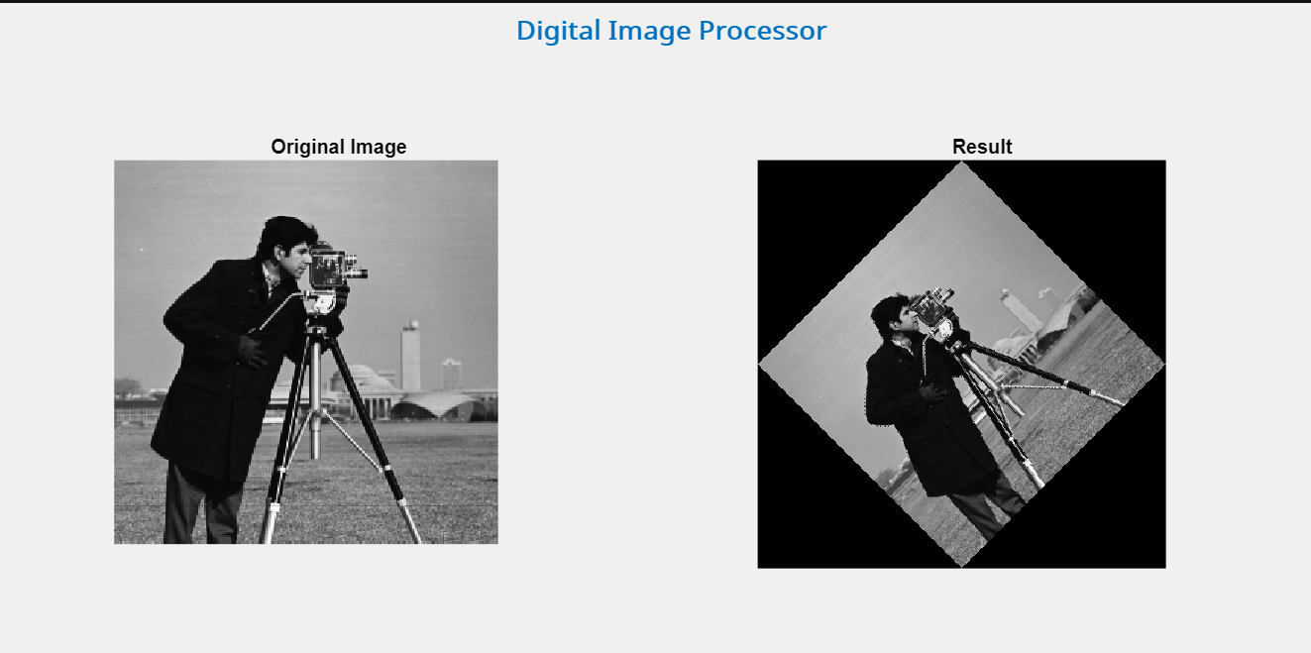Output:

With 90• degrees:

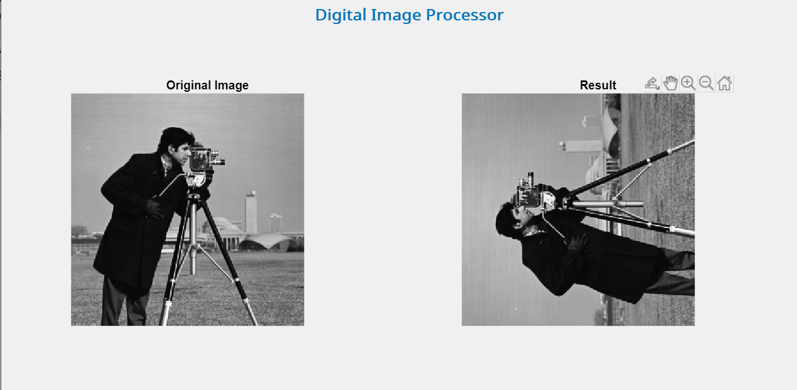

Code:

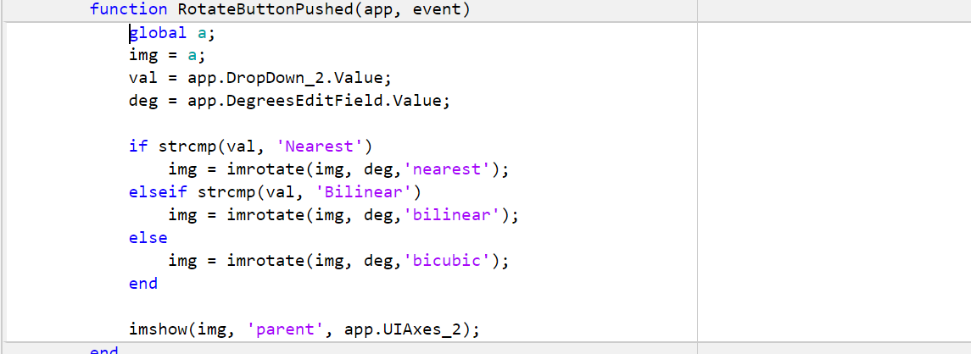

**Zooming:**

The user can zoom the image to have a better look at the image.



Output:

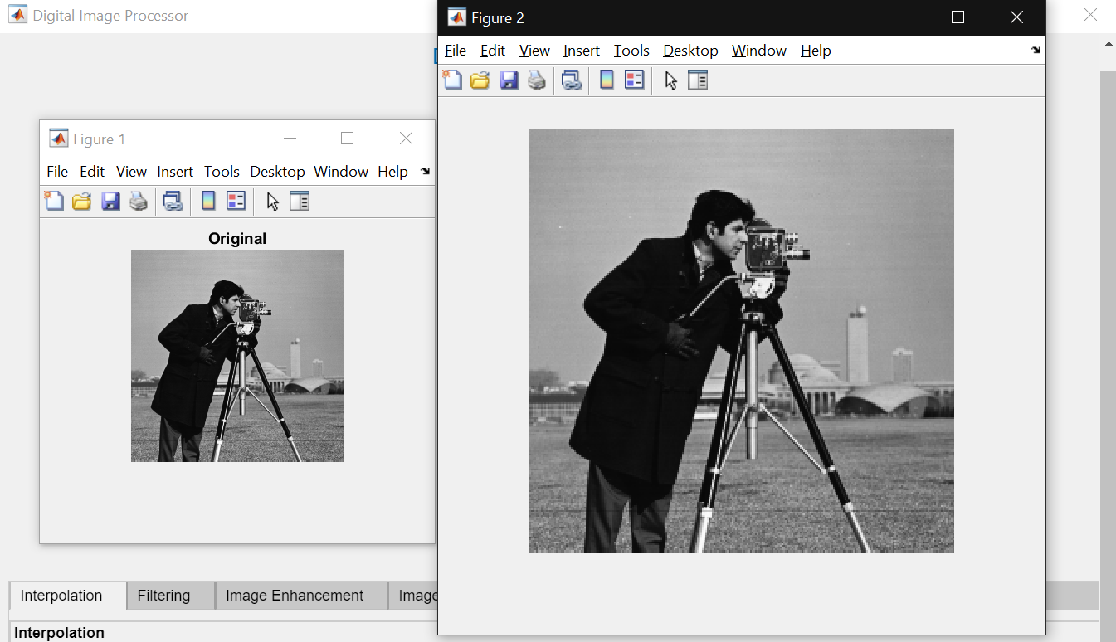

Code:

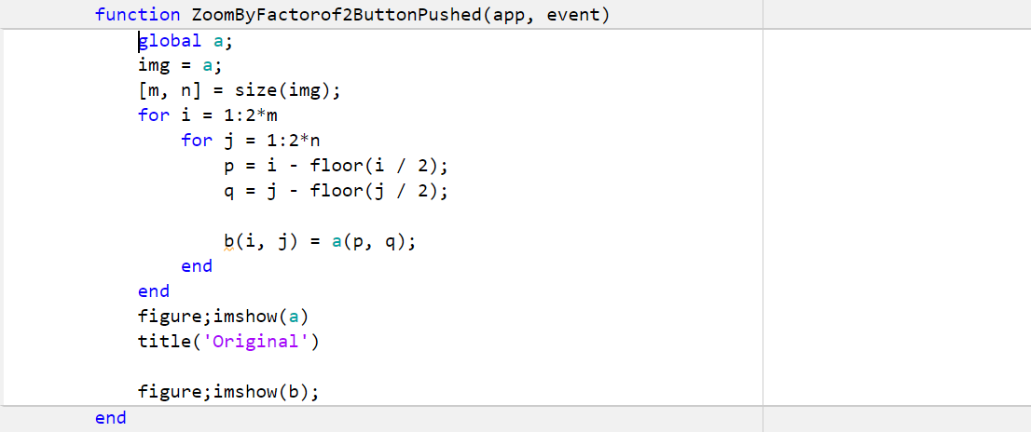

**Shrinking:**

The user has an option to shrink the image.

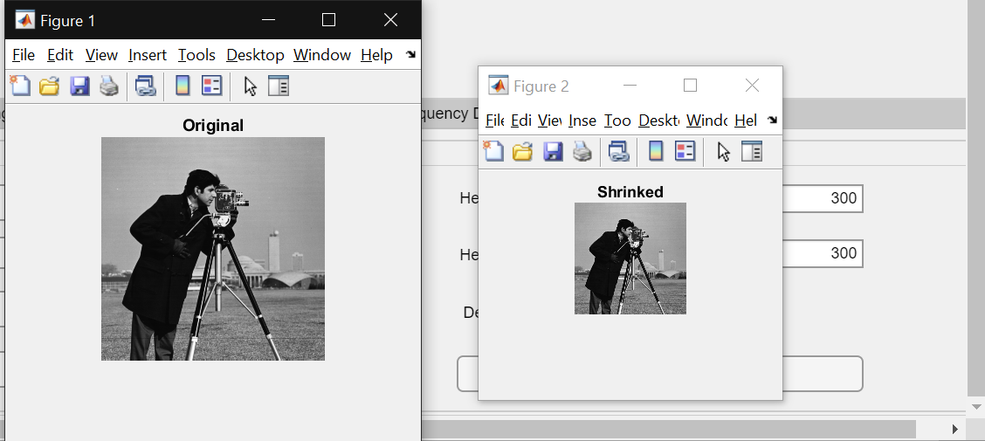Output:

Code:

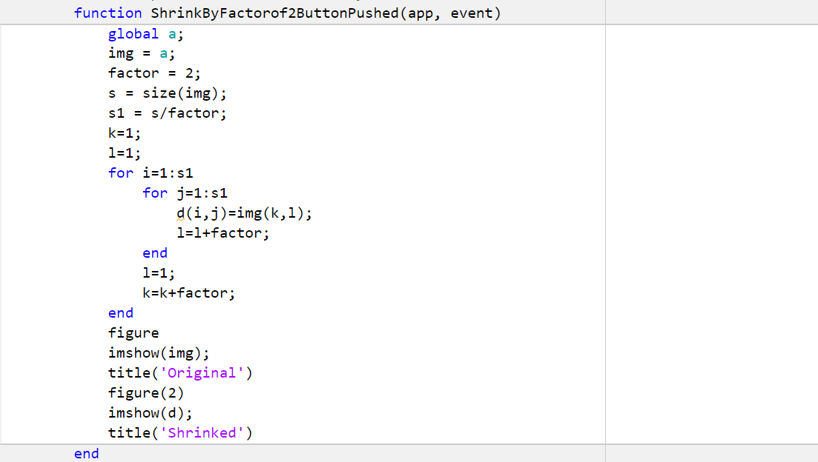

**Task 2: Filtering**

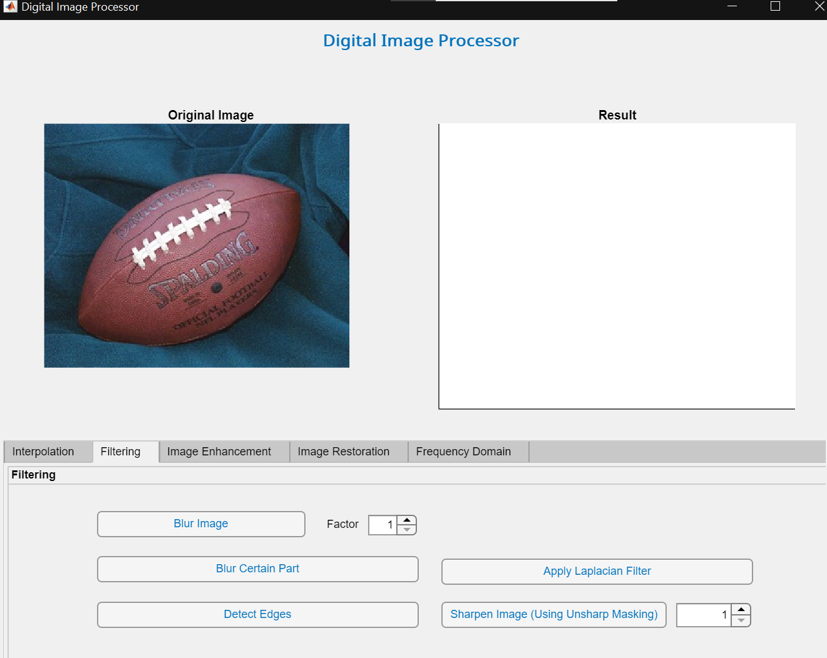Following is the initial interface of the filtering tab. There are mainly 5 operations available to the user in this tab. Let us go through each of them and demonstrate their outputs.

**Blurring:**

The user has the option to blur an image by providing a factor. The higher the factor, the higher the blurring effect in the image will be produced.

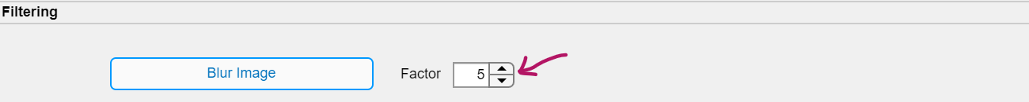

Output:

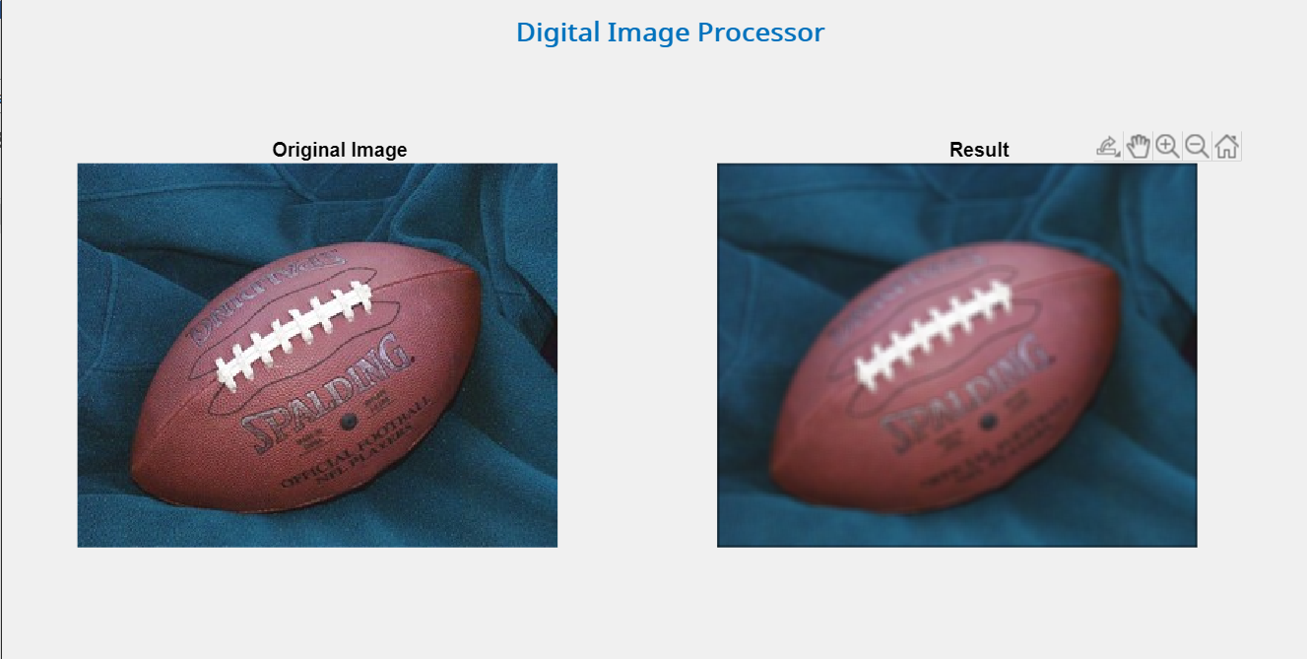

Output with factor = 10:

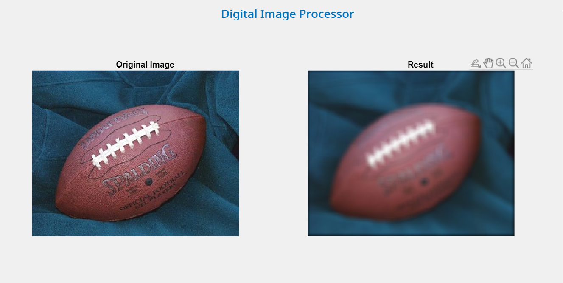

Code:

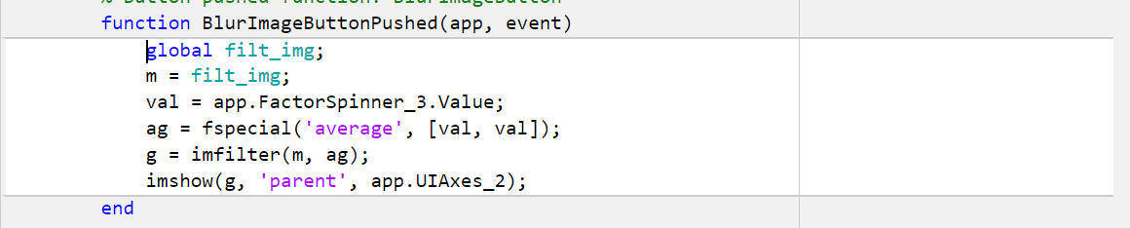

**Blurring A Specific Part of The Image:**

Aside from blurring the whole image, the user has the option to blur the image except for the specific portion of the image that the user selects.



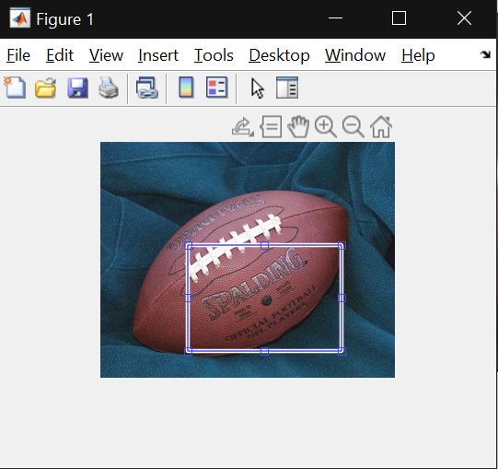Output:

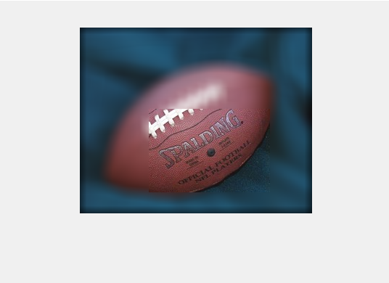

Code:

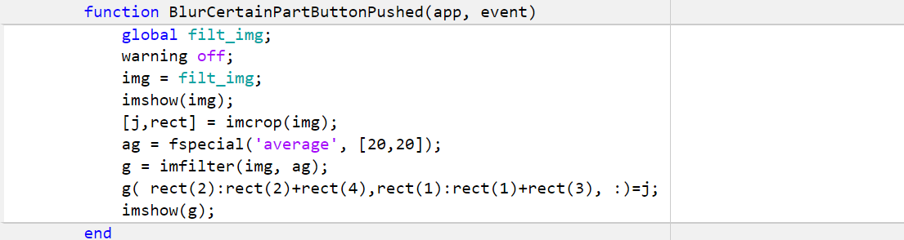

**Detect Edges:**

The user has the option to detect edges in an image, this is achieved using the ‘Sobel’ operator.



Output:

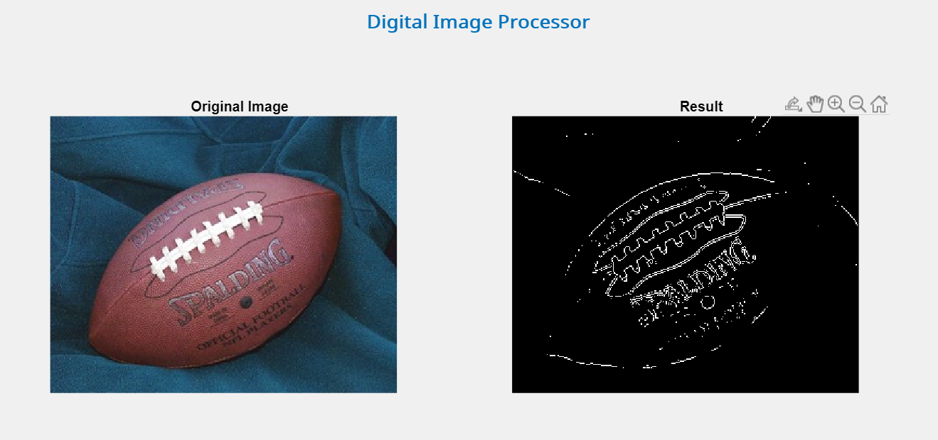

Code:

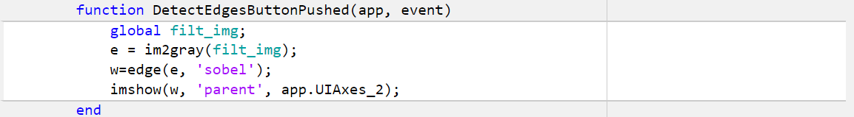

**Sharpening:**

The user can sharpen an image by specifying the factor just as with the blur option.



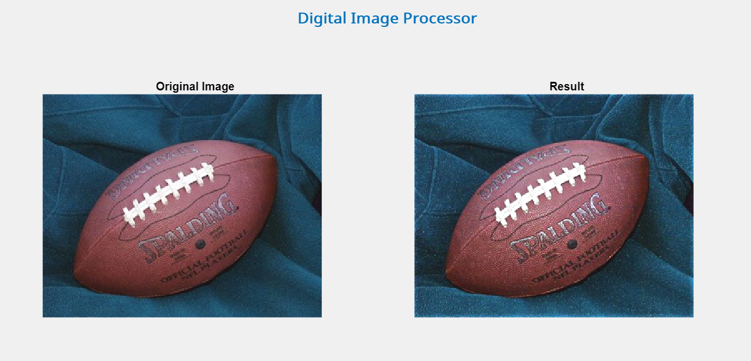Output:

Code:

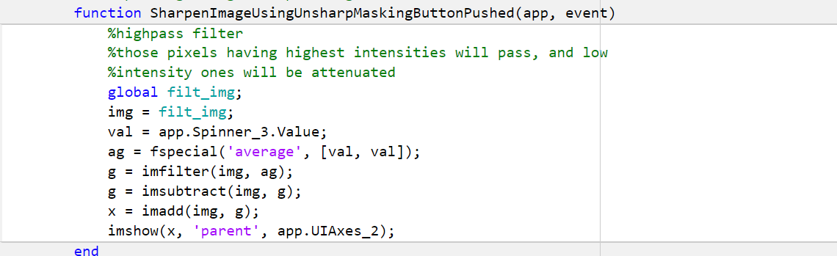

**Task 3: Image Enhancement**

Following is the initial interface of the image enhancement tab.

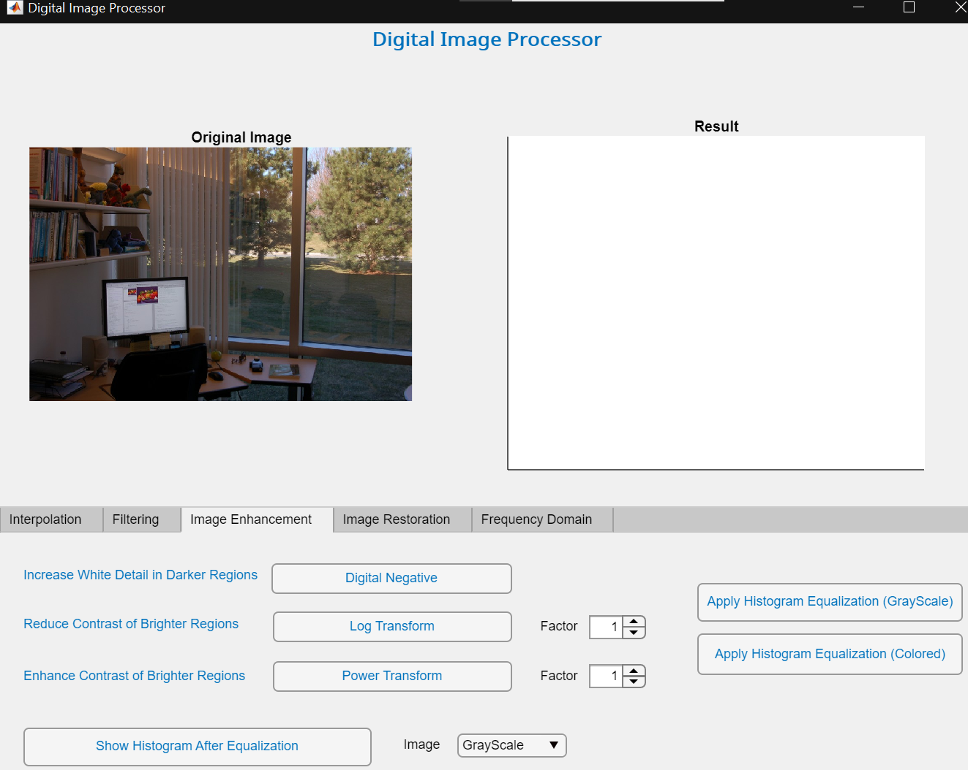

There are 3 linear contrast functions that the user can apply on an image. In addition to the linear contrast functions, the user can enhance the image using histogram equalization. Let us demonstrate the output of each operation.

**Digital Negative:**

The user can increase white detail in darker regions using the digital negative operation.

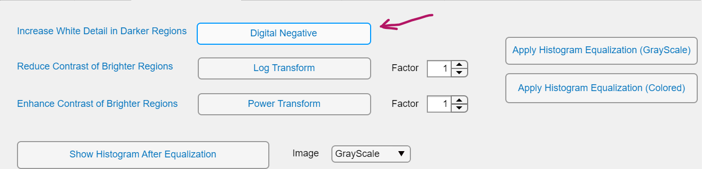

Output:

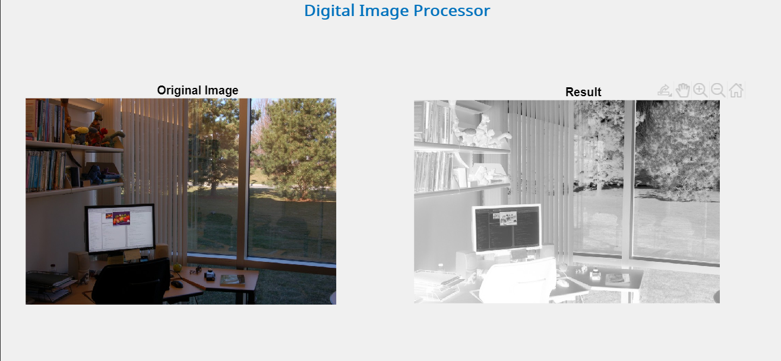

Code:

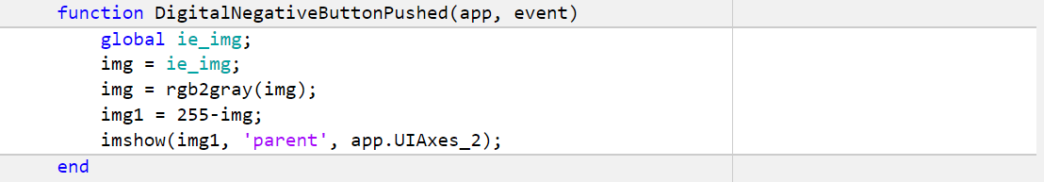

**Log Transform:**

The user can reduce the contrast of brighter regions while enhancing the regions with lower contrast. In addition, the user can specify the factor of the log transformation as well.



Output:

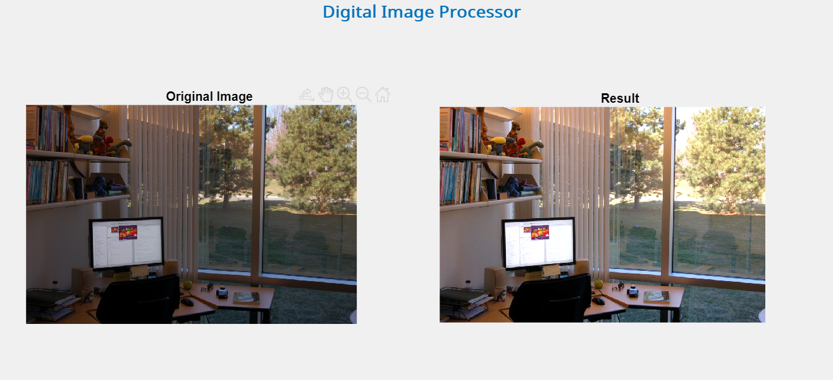

Code:

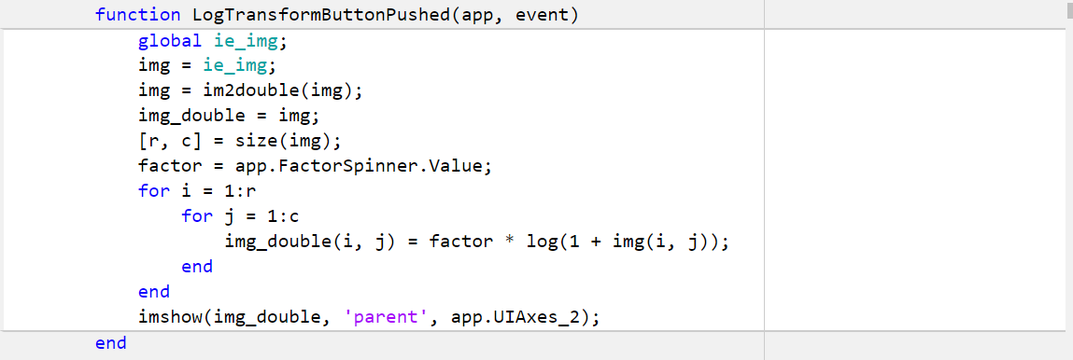

**Power Transform:**

The user can enhance the contrast of brighter regions while compressing the darker regions.

Output:

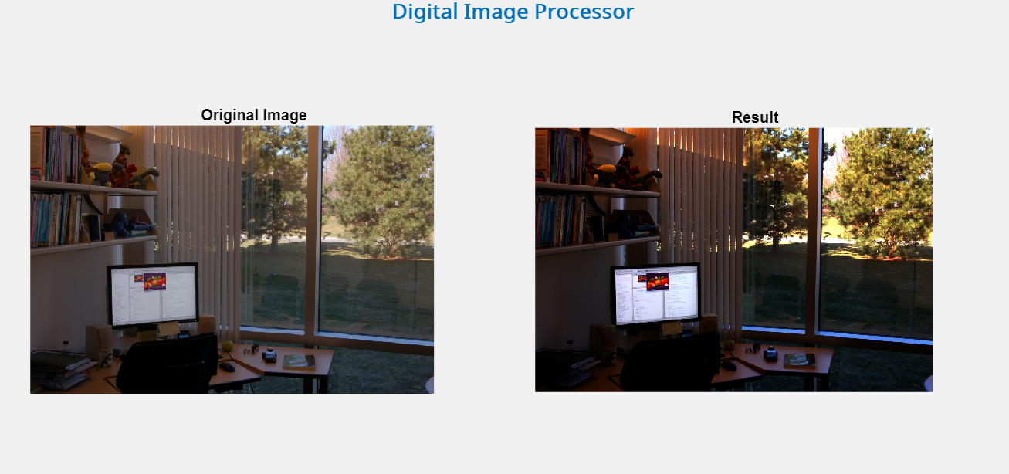

Code:

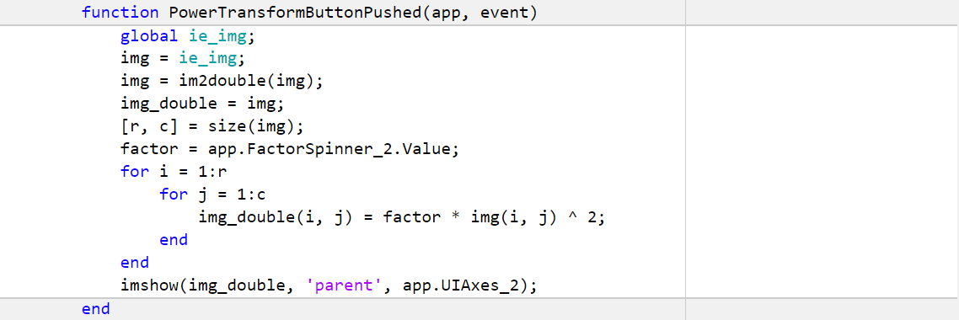

**Histogram Equalization:**

The user can adjust the contrast of an image using the histogram equalization technique. It spreads out the most frequent intensities.

Output:

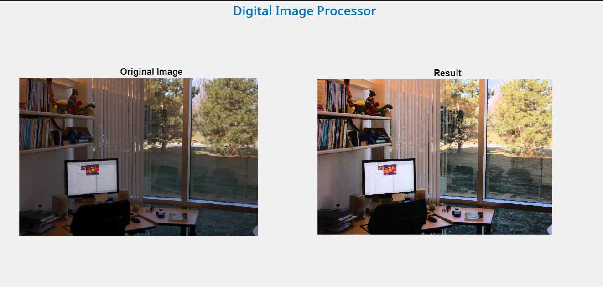

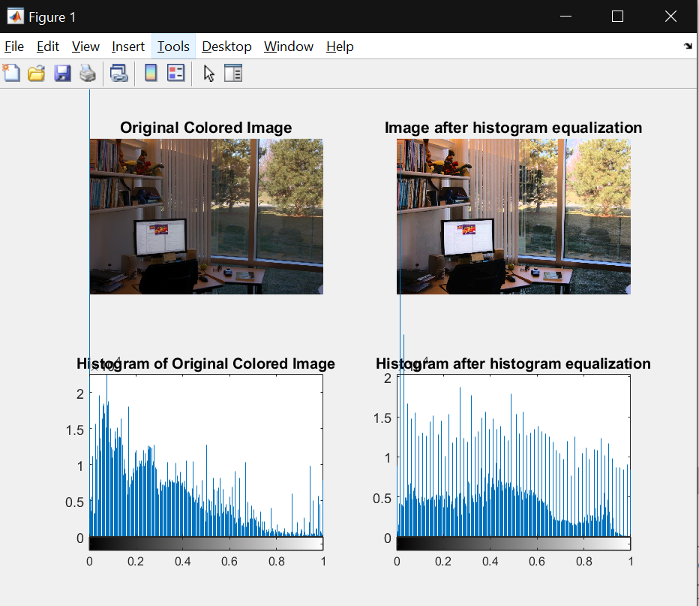

Code:

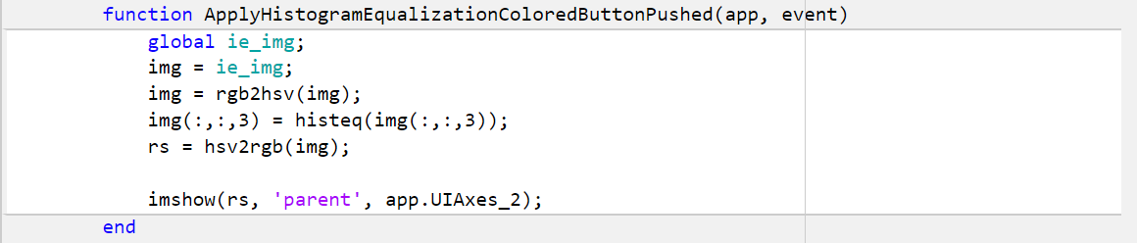

**Task 4: Image Restoration**

Following is the initial interface of the image restoration tab. The user can add the specific noise and try to restore the image by applying different filters provided on the right-hand side.

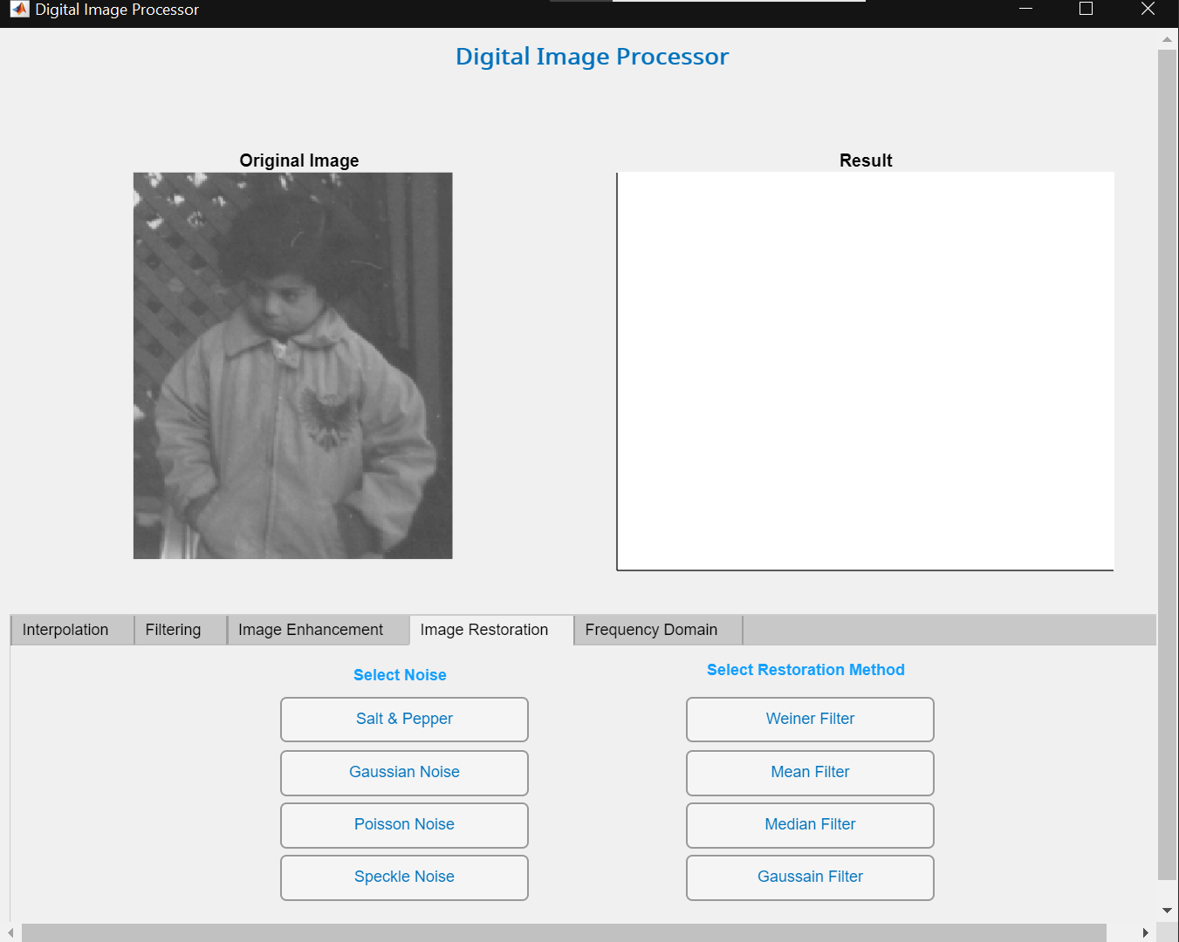

**Salt and Pepper Noise:**

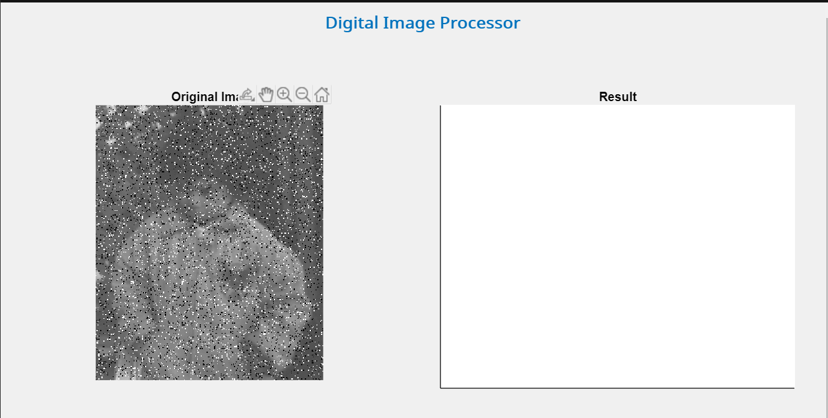

Removal of the noise using **Weiner filter**:

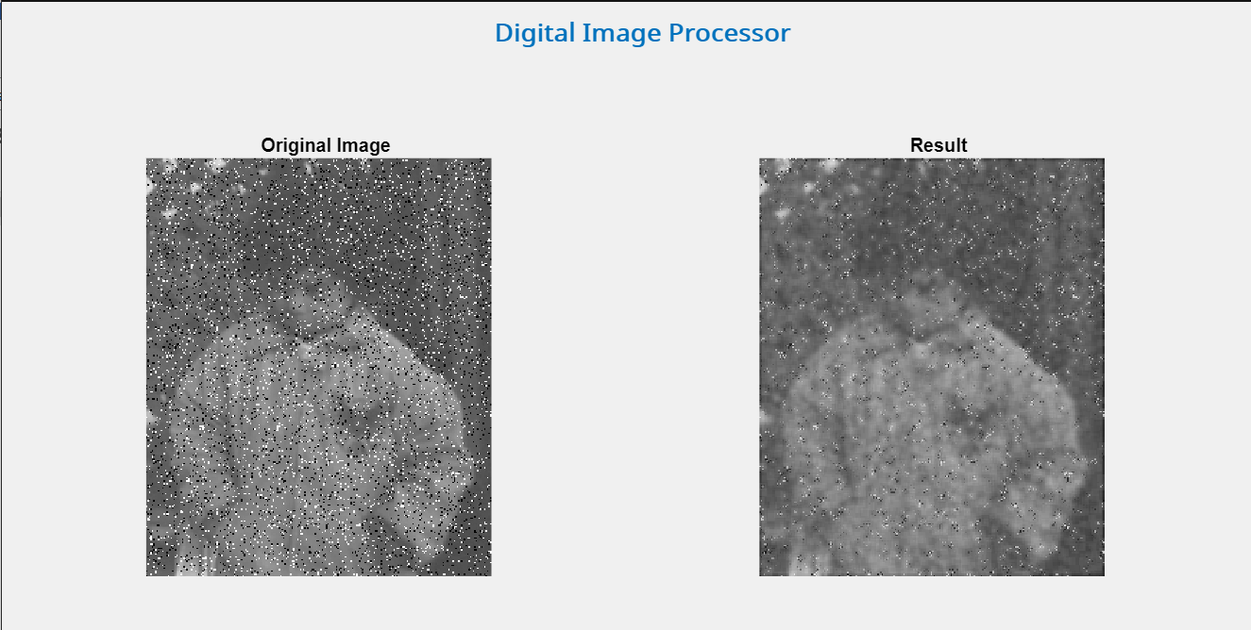

Removal of the salt and pepper noise using **Mean filter**:

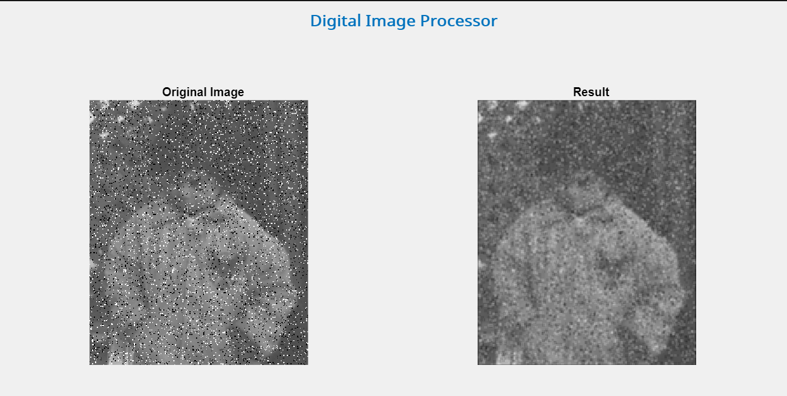

Removal of salt and pepper using **Median filter**:

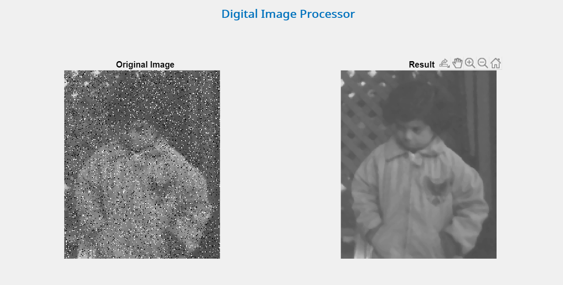

Removal of the salt and pepper using **Gaussian filter**:

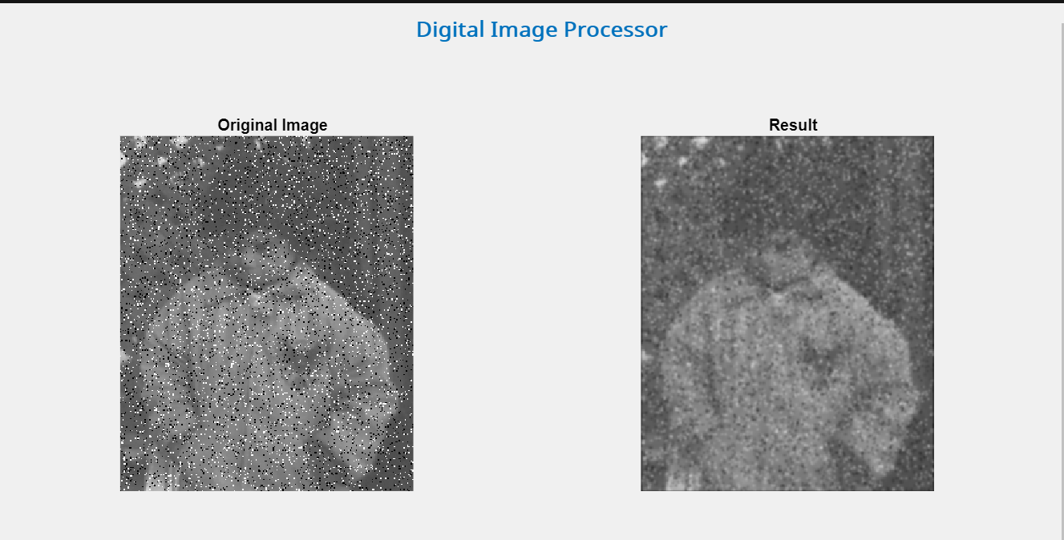

**Gaussian Noise:**

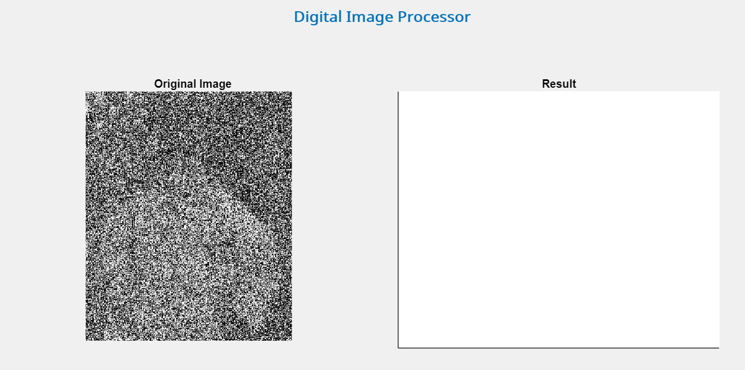

Removal of the gaussian noise using **Weiner filter:**

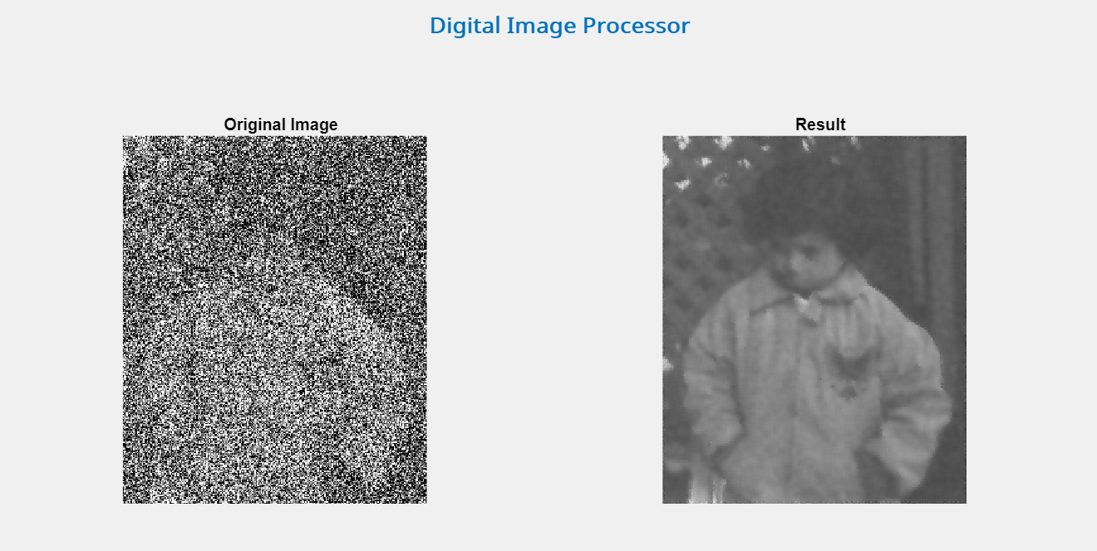

Removal of the gaussian noise using **Mean filter**:

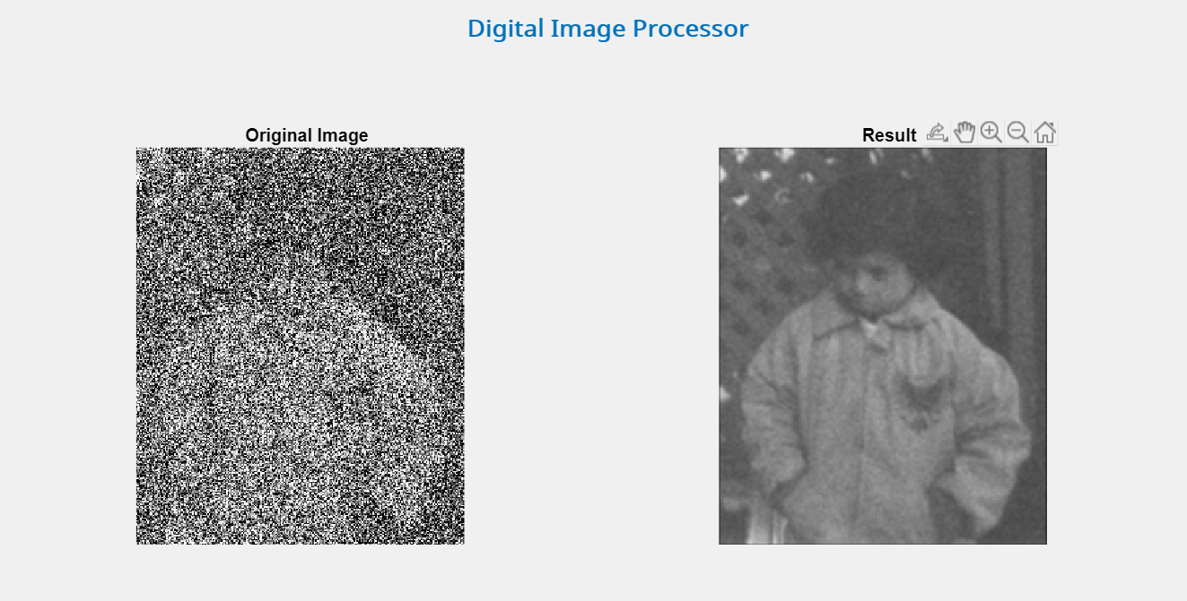

Removal of the gaussian noise using **Median filter**:

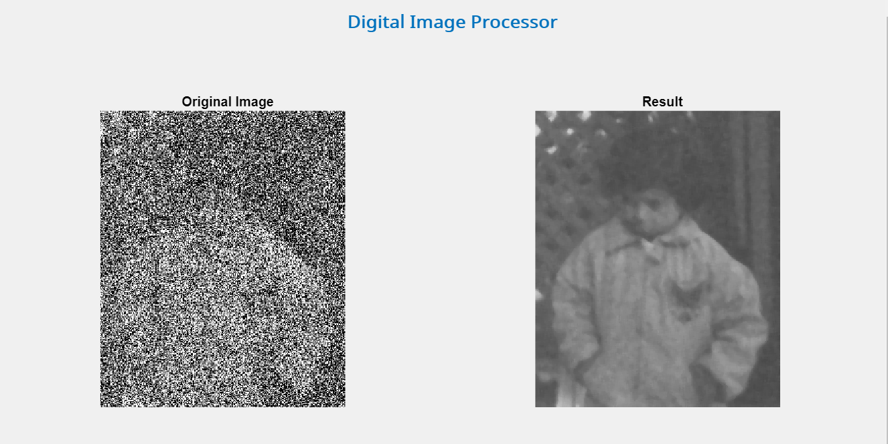

Removal of the gaussian noise using **Gaussian filter**:

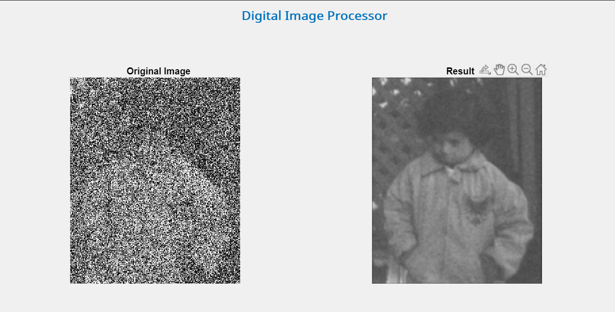

**Poisson Noise:**

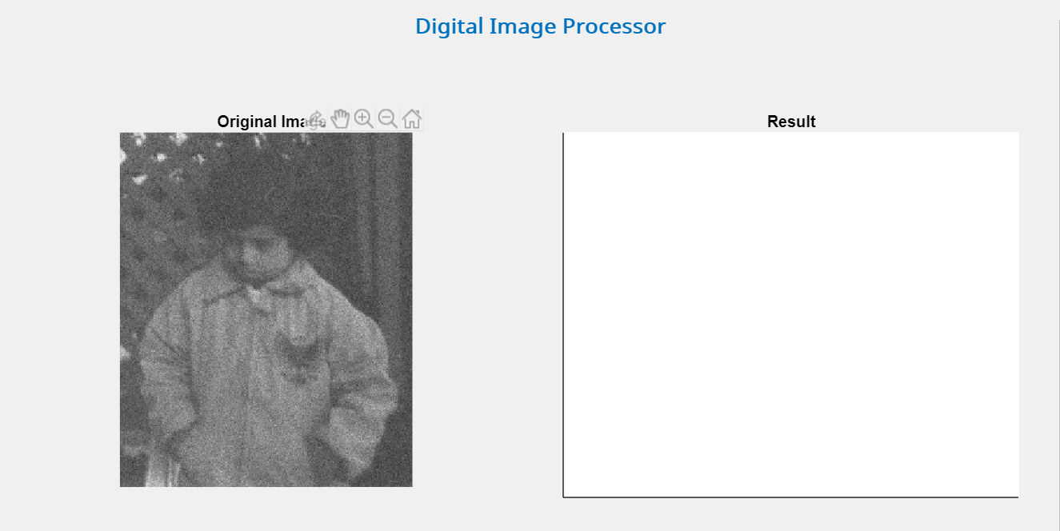

Removal of the Poisson noise using the **Weiner filter**:

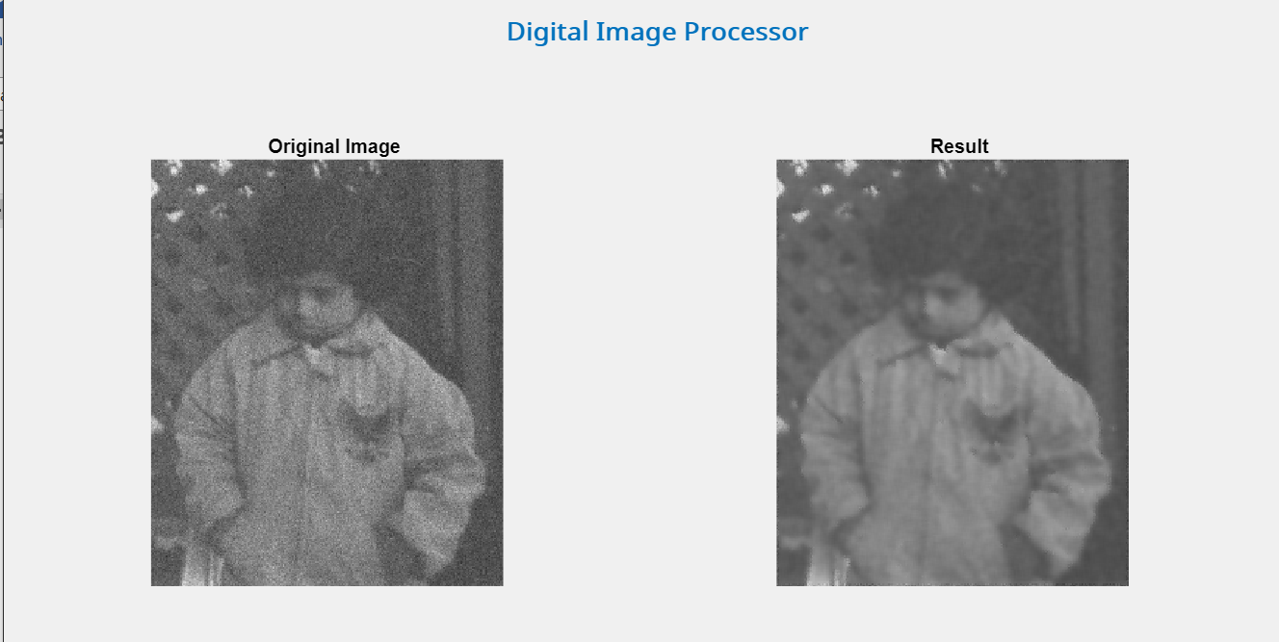

Removal of the Poisson noise using the **Mean filter**:

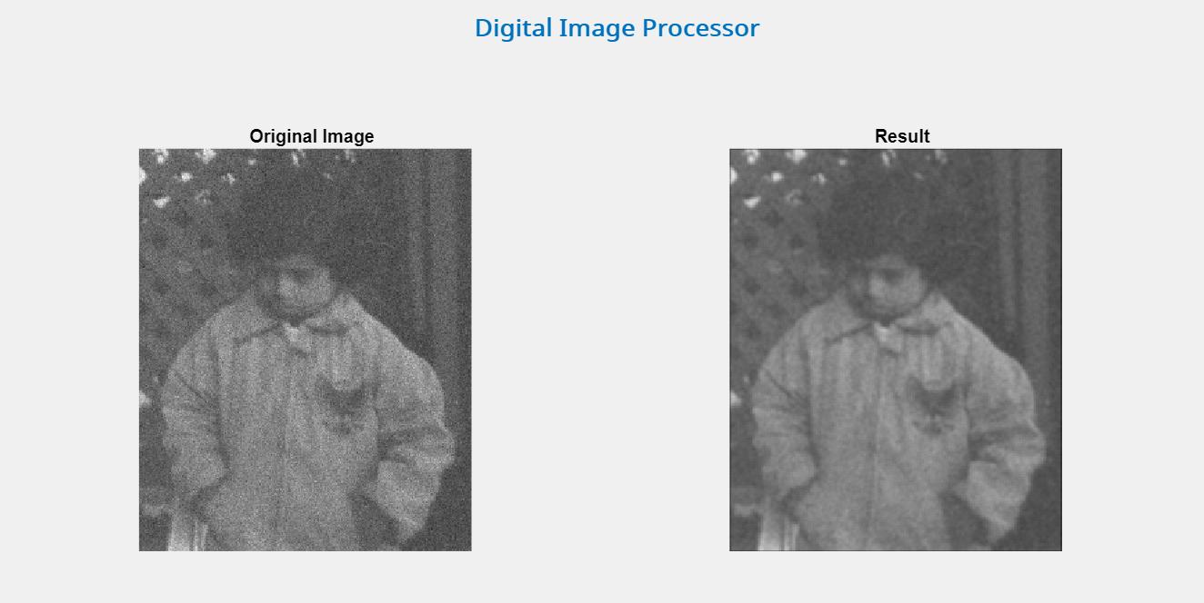

Removal of the Poisson noise using the **Median filter**:

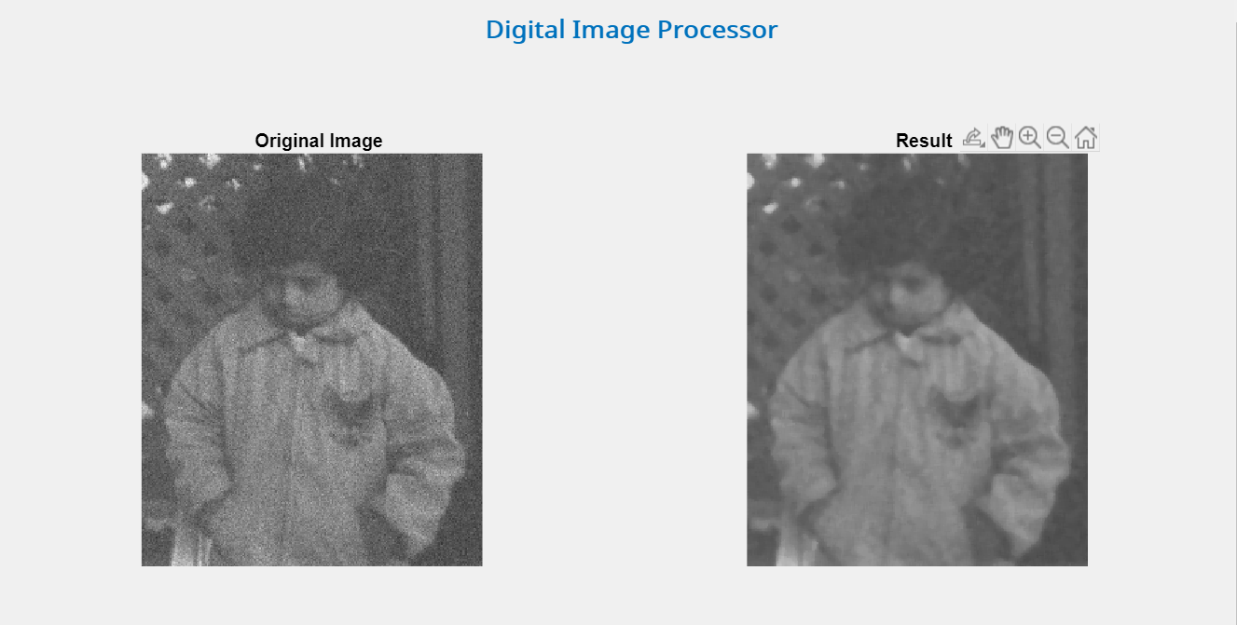

Removal of the Poisson noise using the **Gaussian filter**:

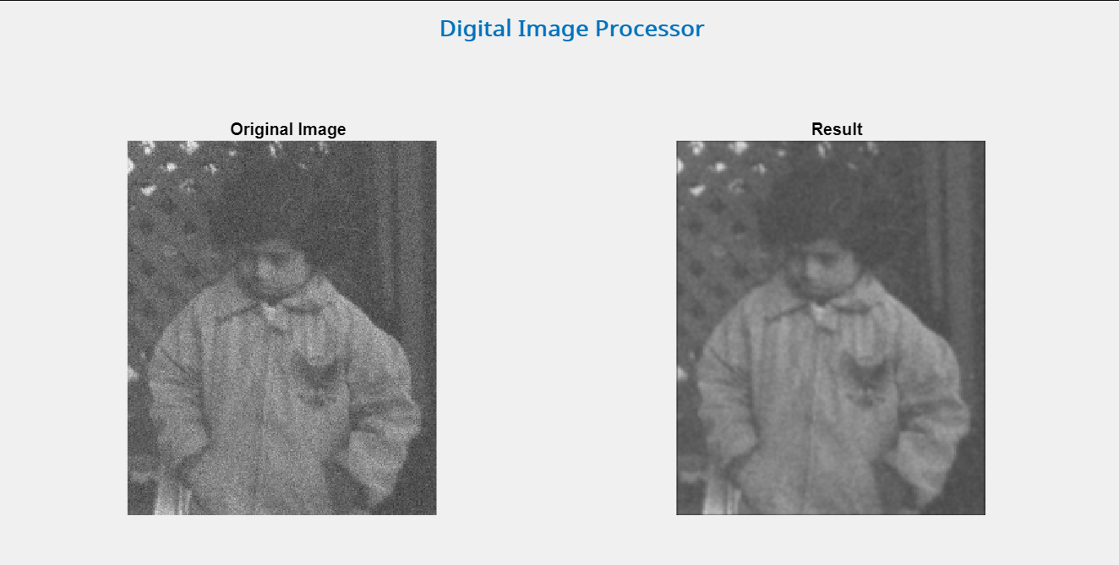

**Speckle Noise:**

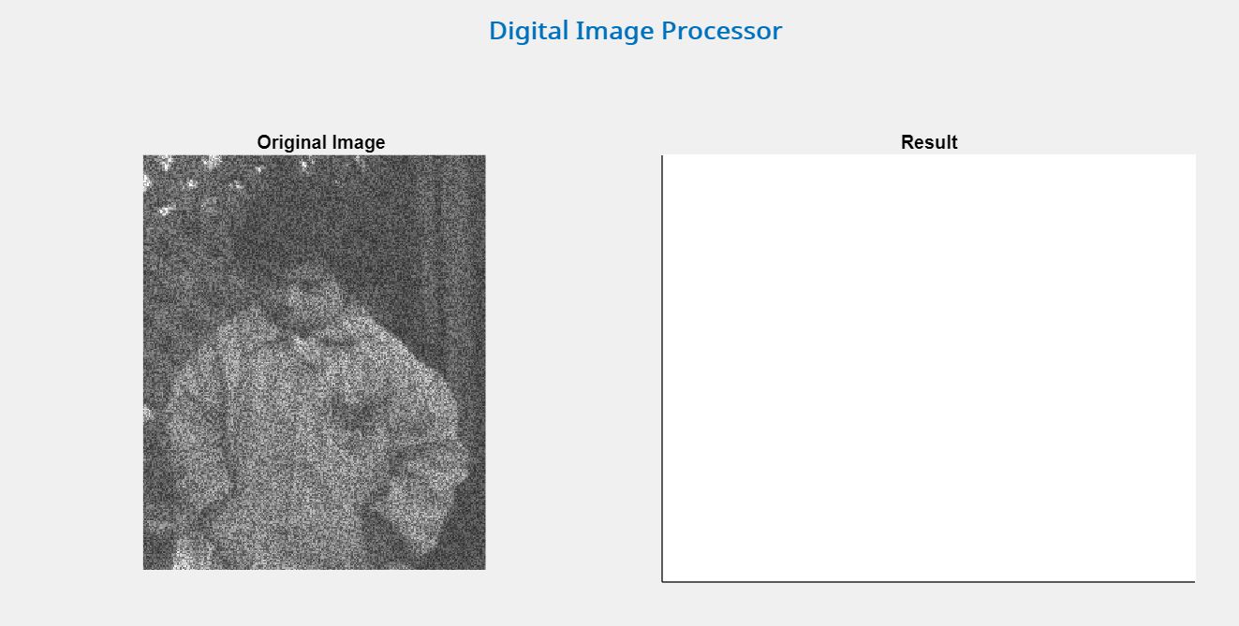

Removal of the Speckle noise using the **Weiner filter**:

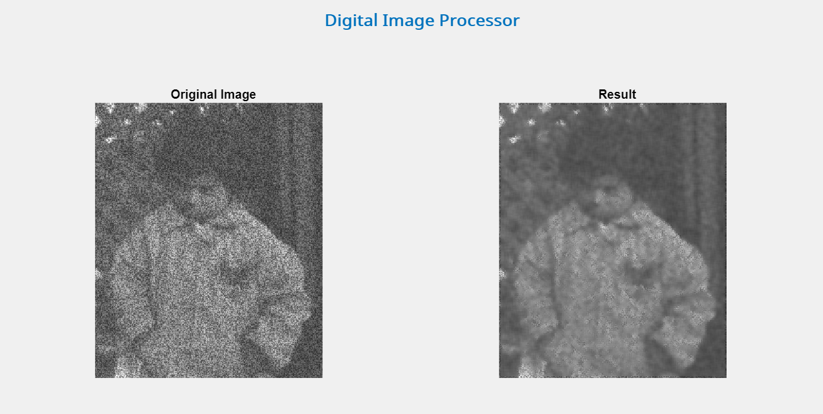

Removal of the Speckle noise using the **Mean filter**:

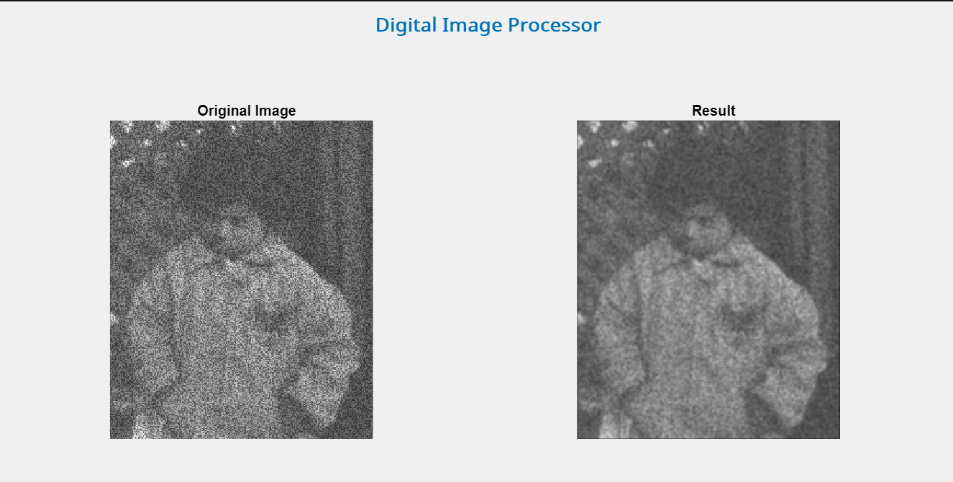

Removal of the Speckle noise using the **Median filter**:

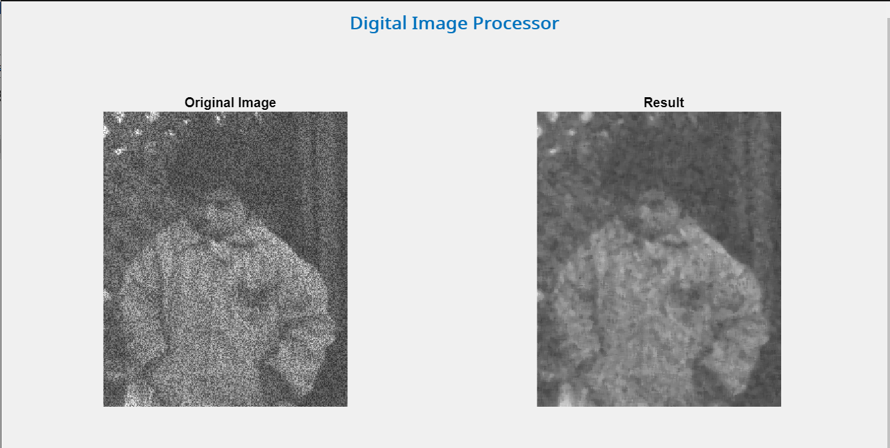

Removal of the Speckle noise using the **Gaussian filter**:

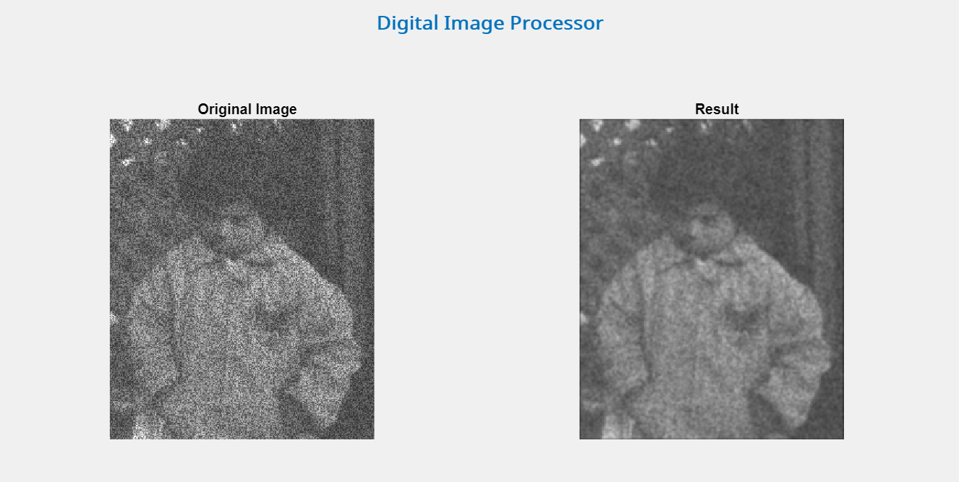

Following are the codes.

**Code for the Weiner Filter:**

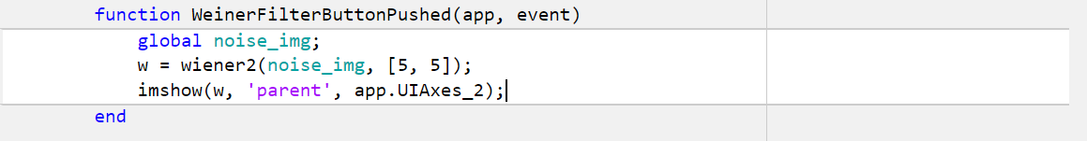

**Code for the Mean Filter:**

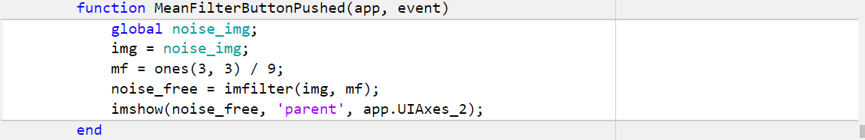

**Code for the Median Filter:**

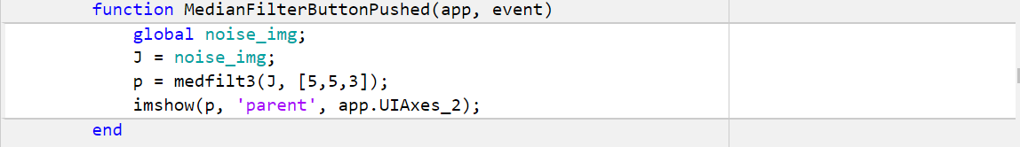

**Code for the Gaussian Filter:**

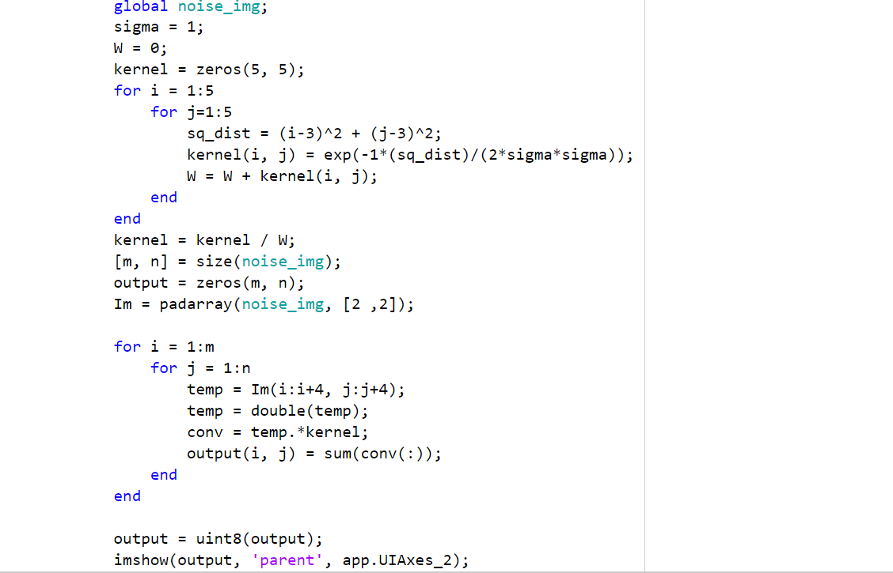

**Task 5: Frequency Domain Filtering**

Following is the initial interface of the frequency domain tab. The user can perform smoothing as well as sharpening using the provided filters in the tab.

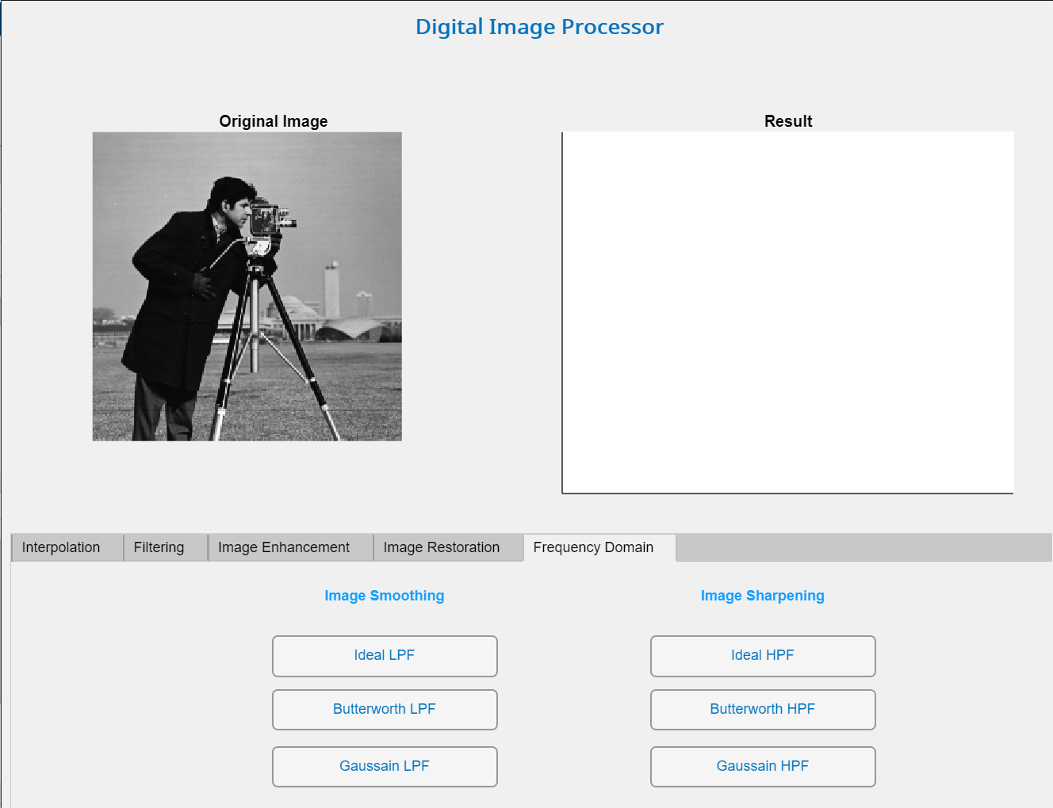

**Ideal Low Pass Filter:**

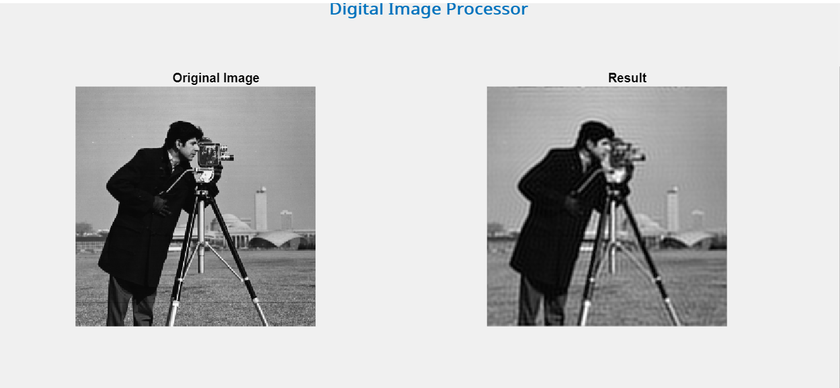

Following shows the Fourier transform and the surface plot of the Ideal LPF.

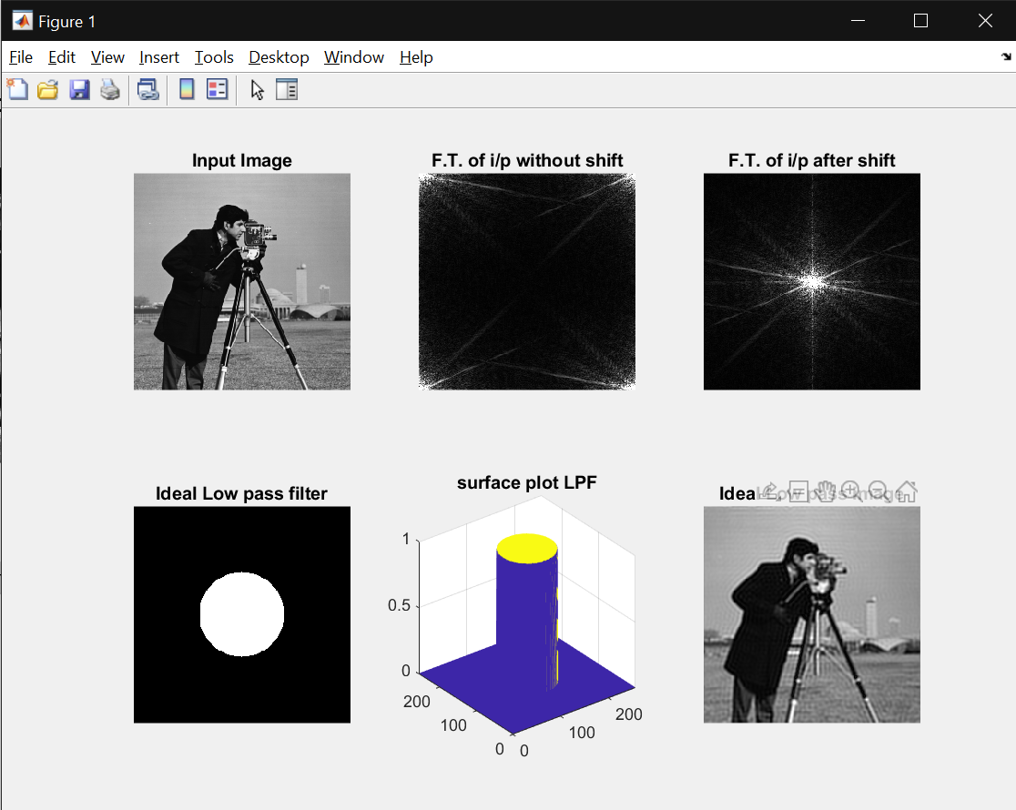

Code:

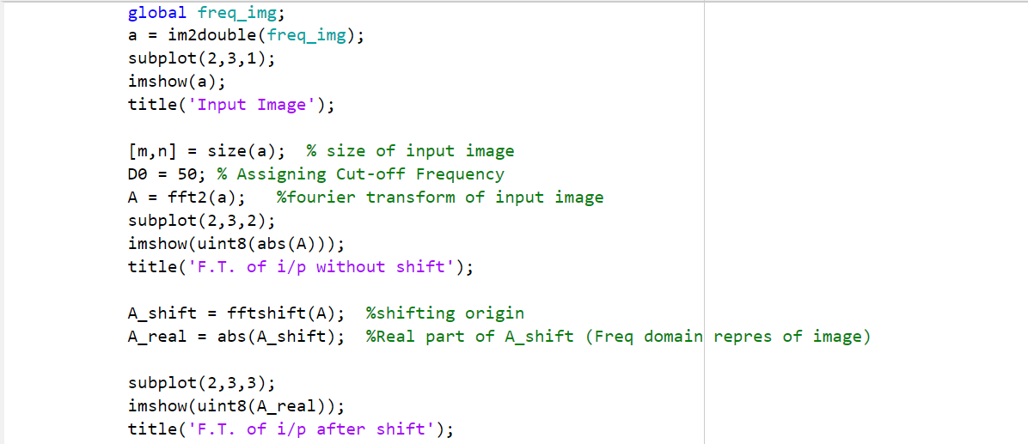

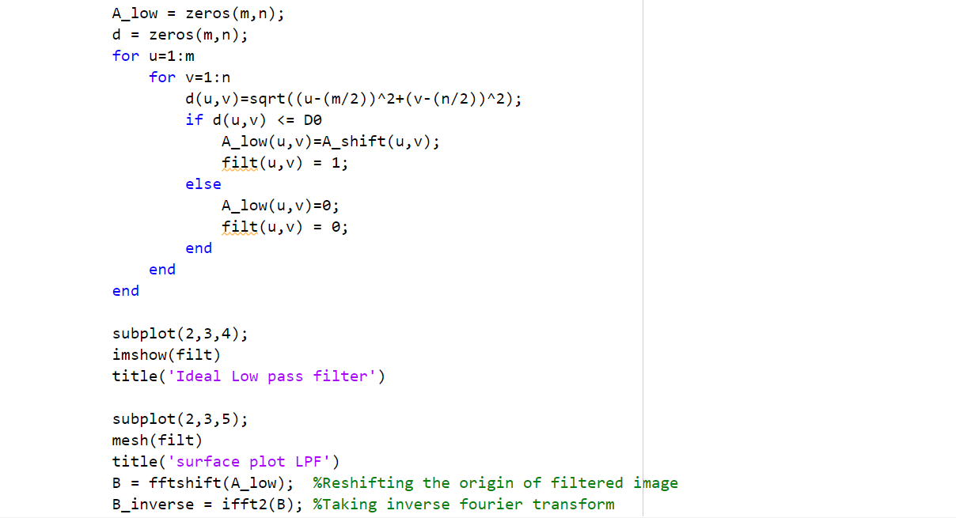

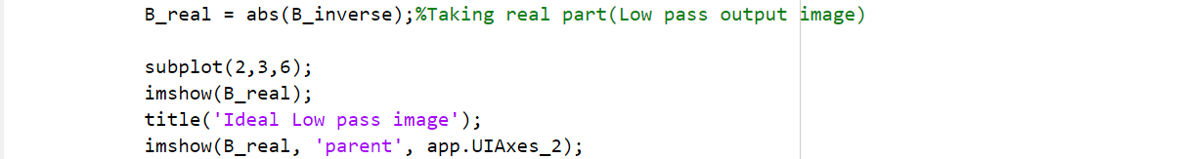

**Butterworth Low Pass Filter:**

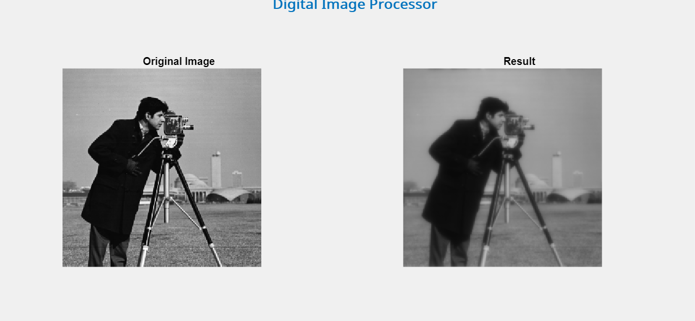

Following shows the Fourier transform and the surface plot of the Butterworth LPF.

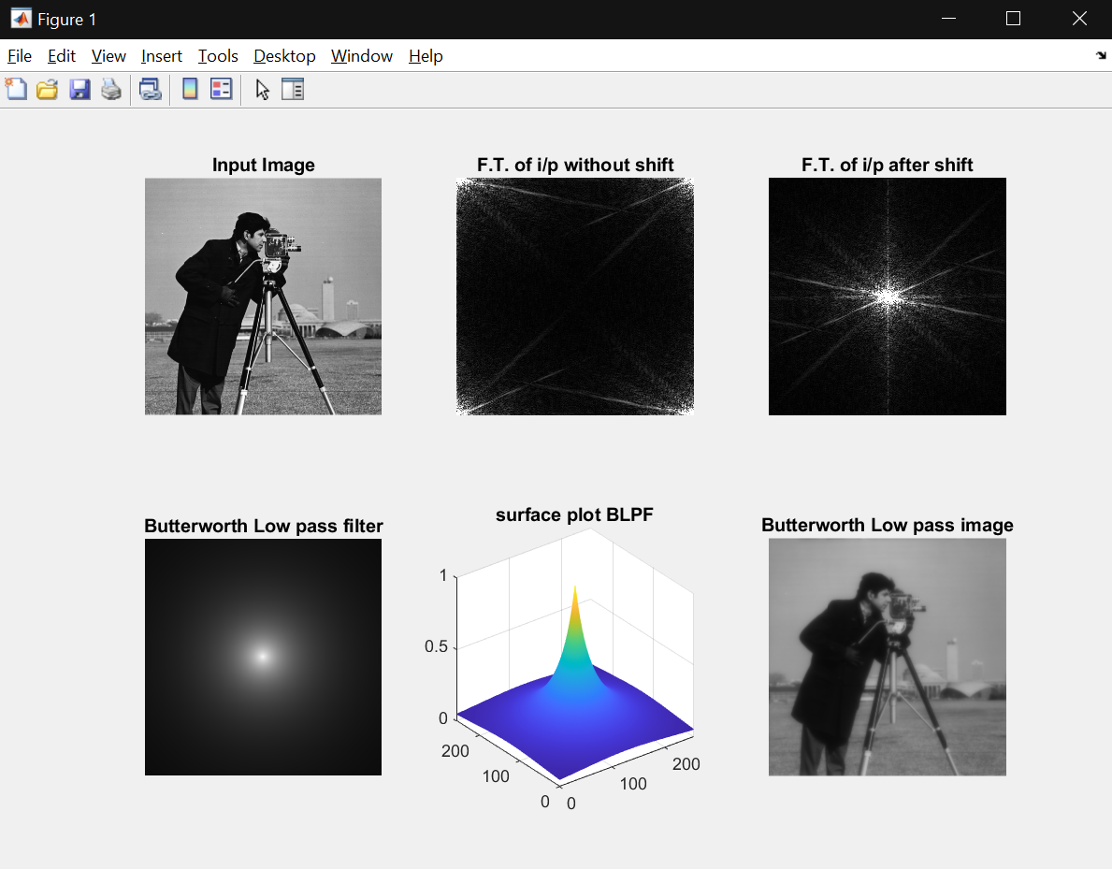

Code:

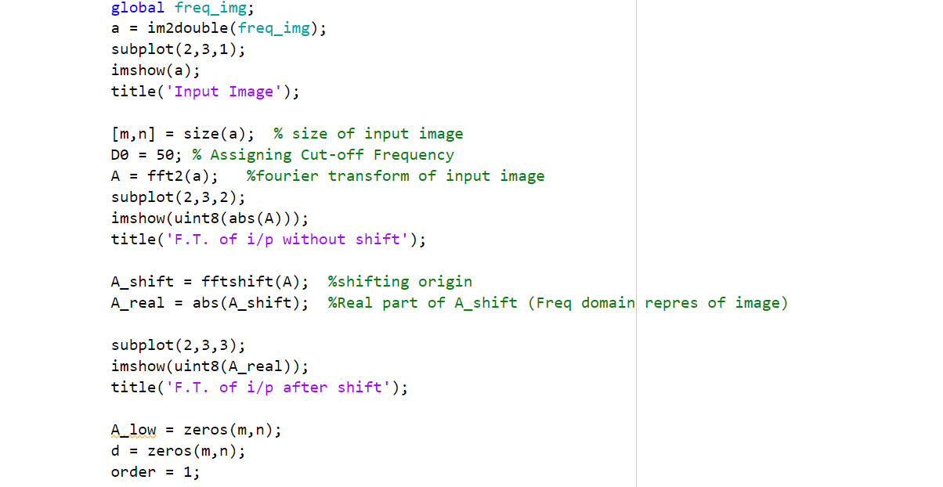

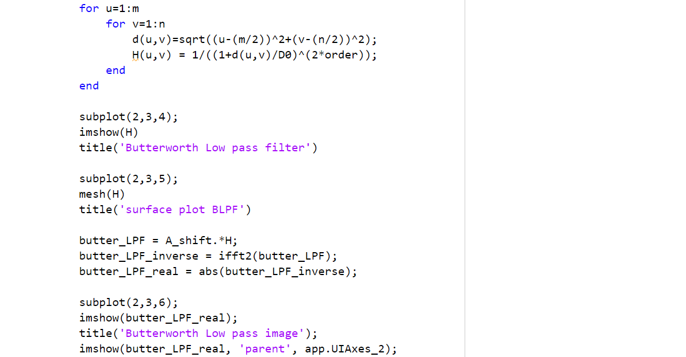

**Gaussian Low Pass Filter:**

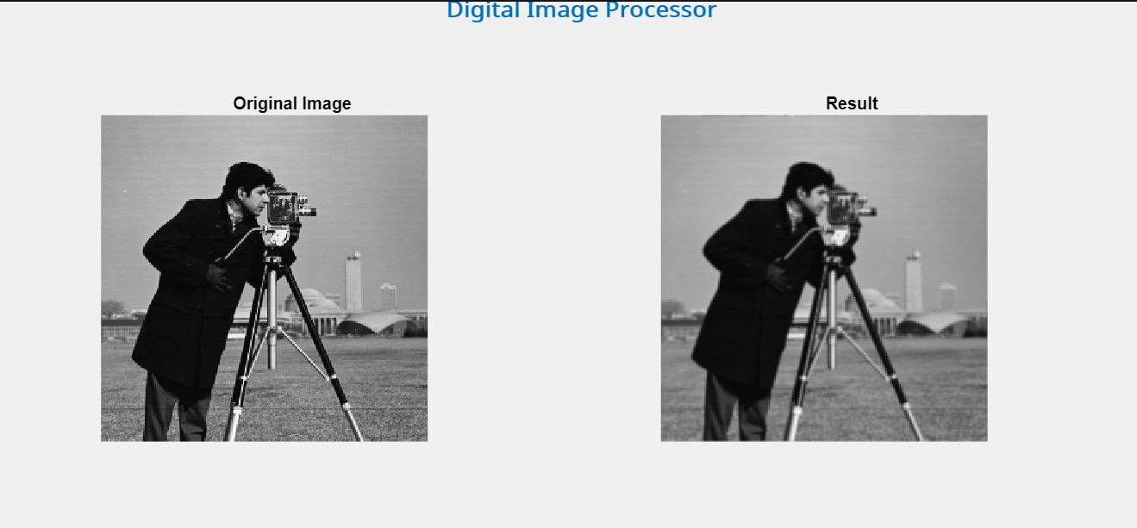

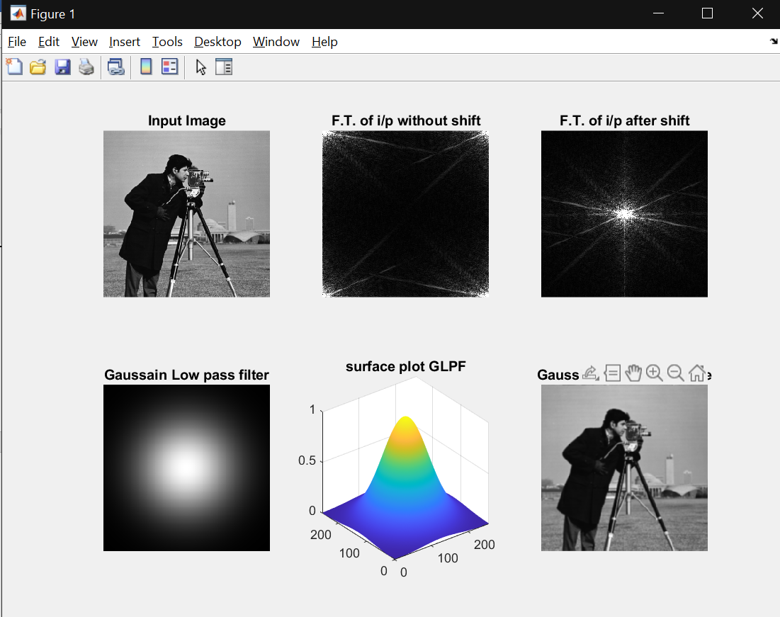

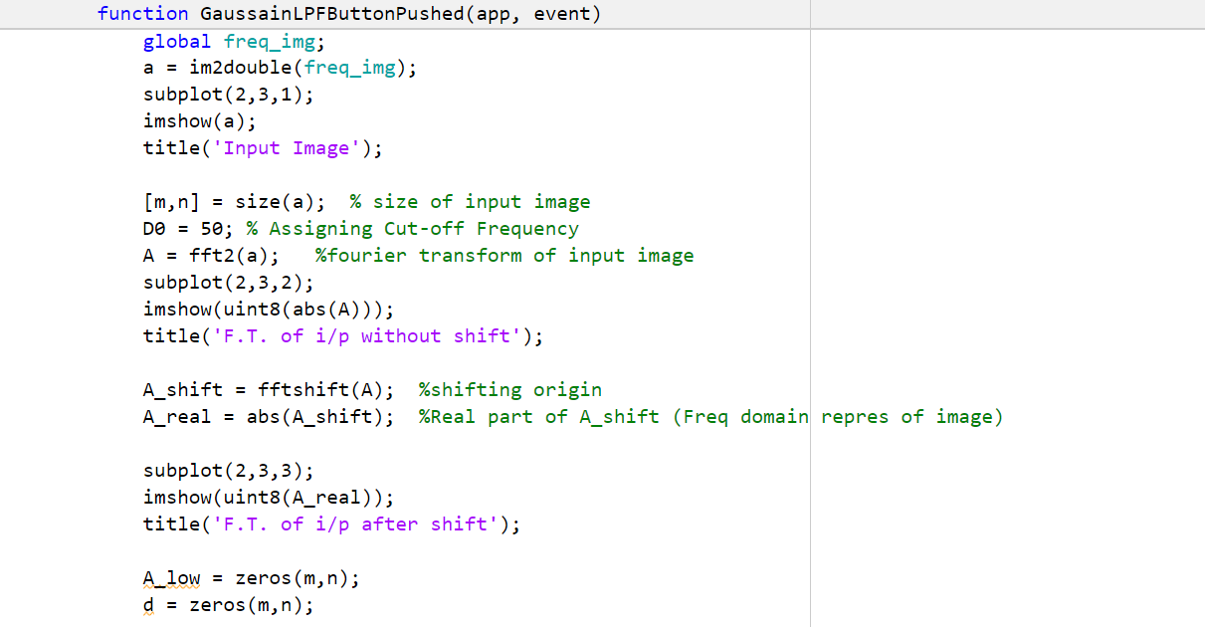Code:

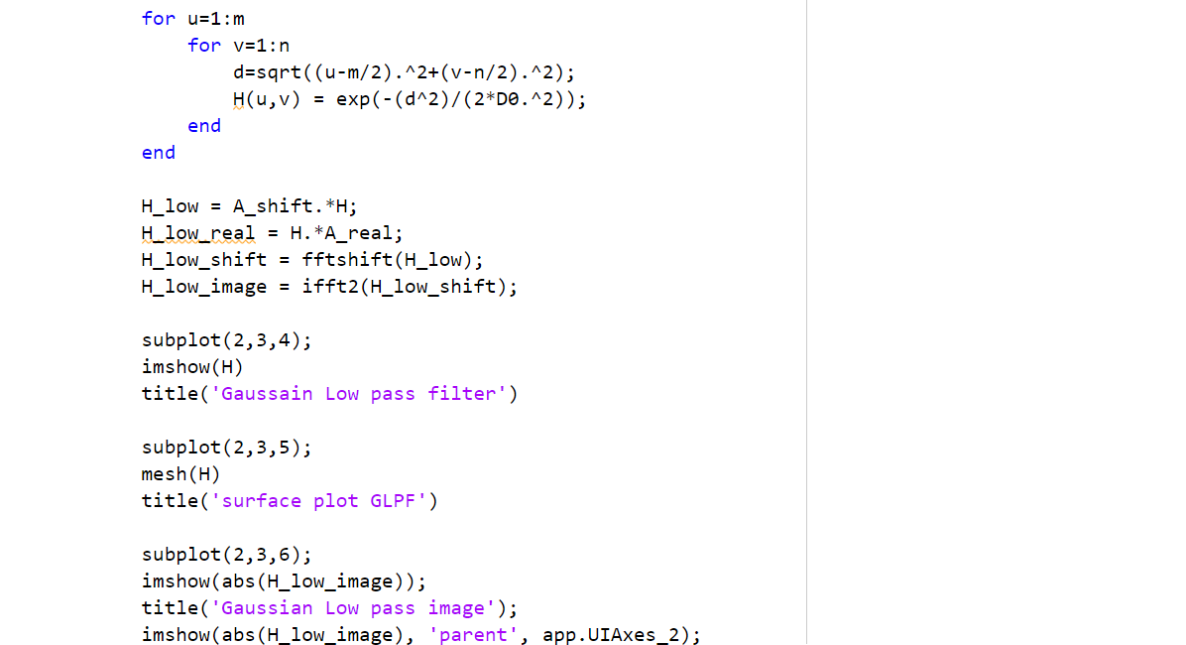

**Ideal High Pass Filter:**

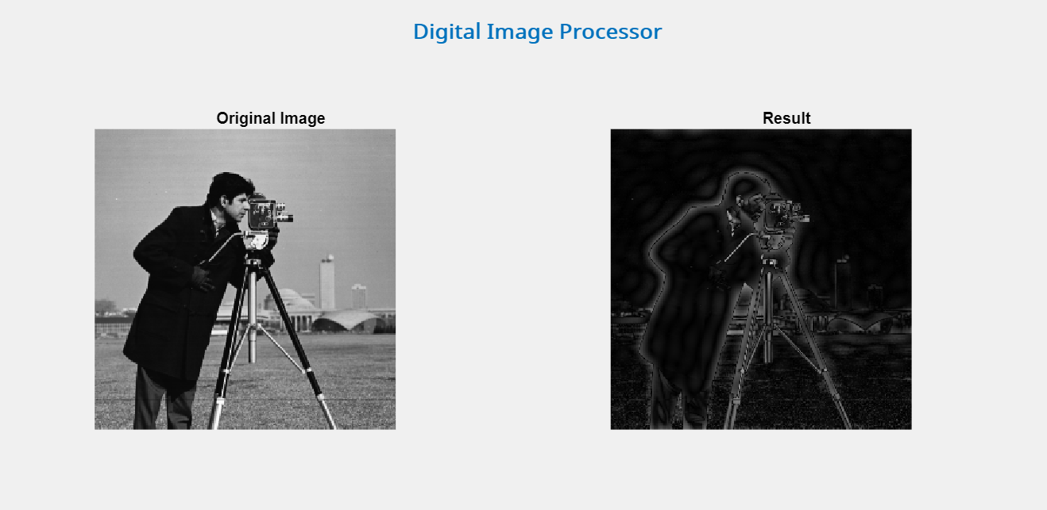

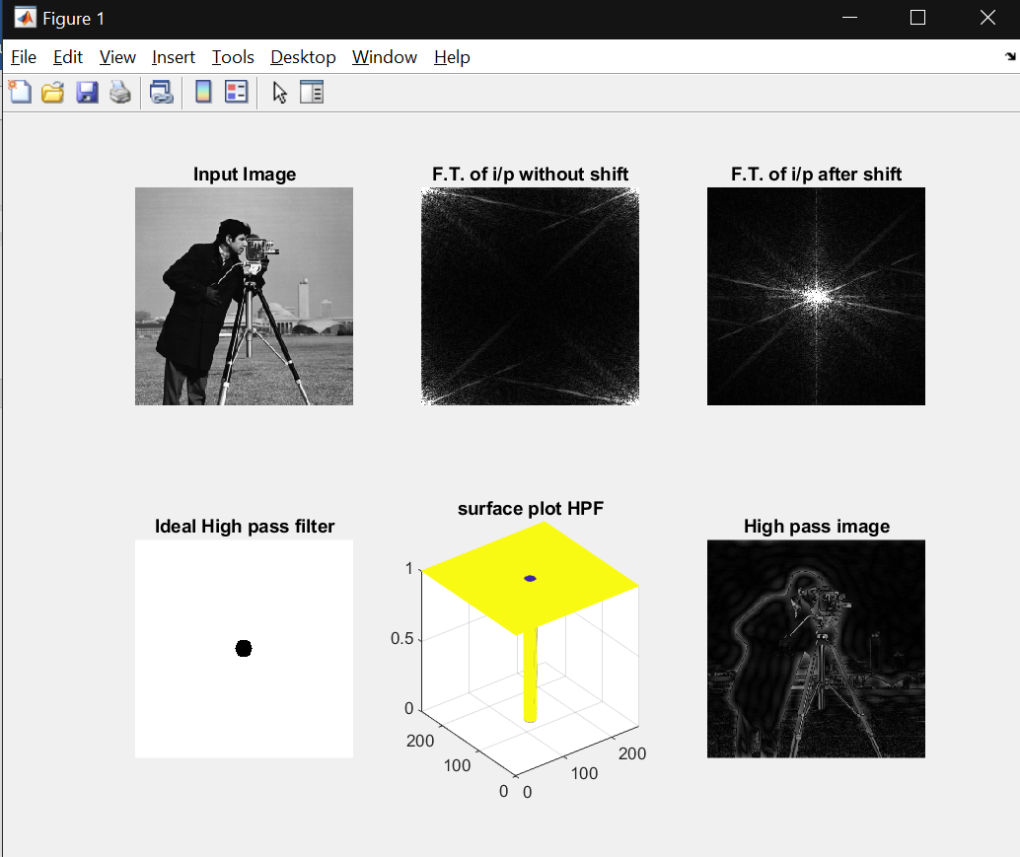

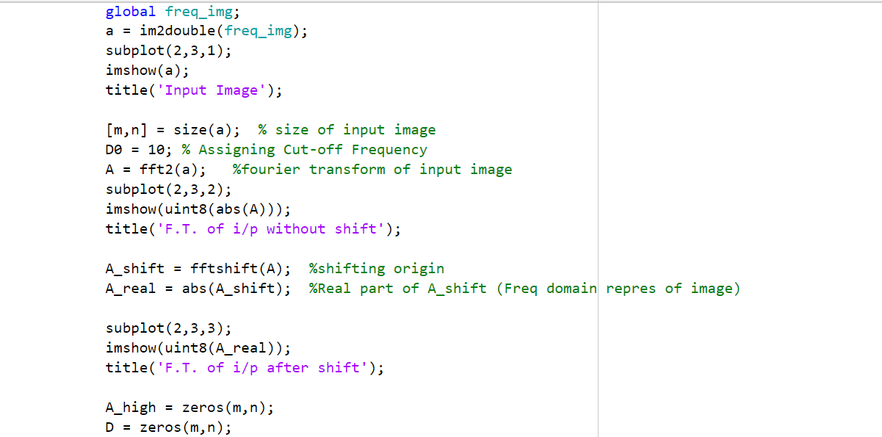Code:

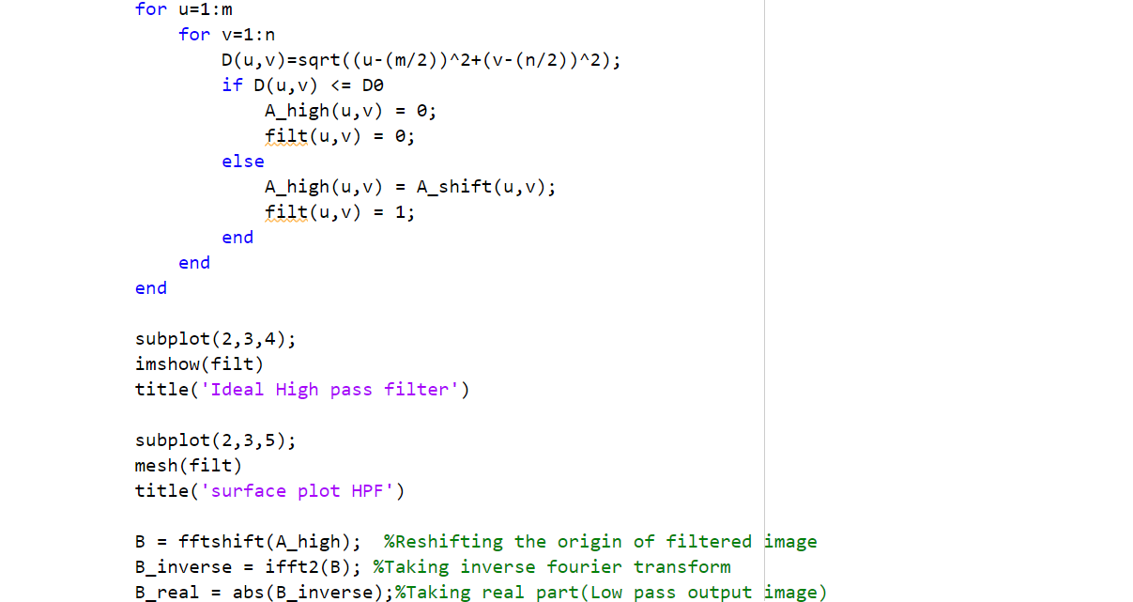



**Butterworth High Pass Filter:**

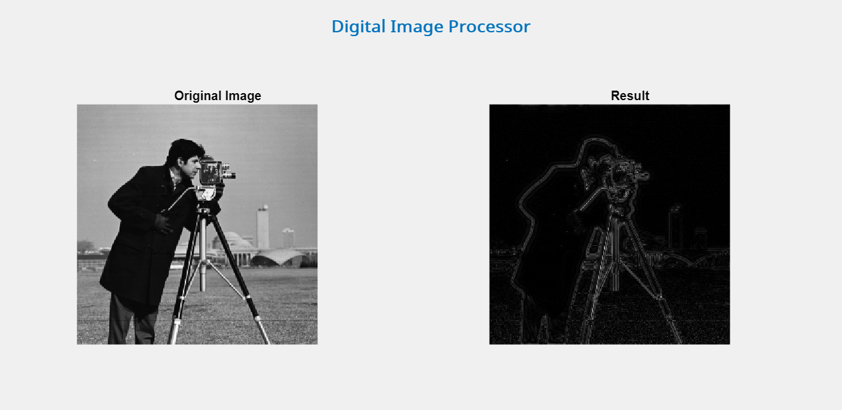

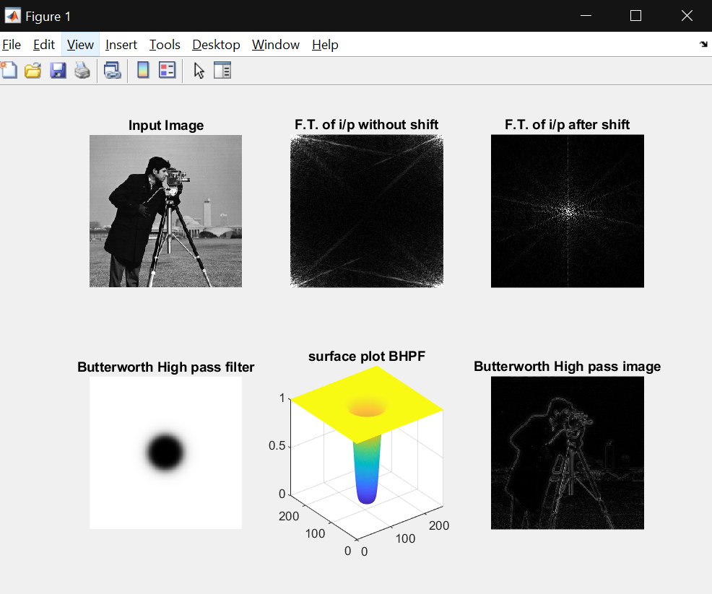

Code:

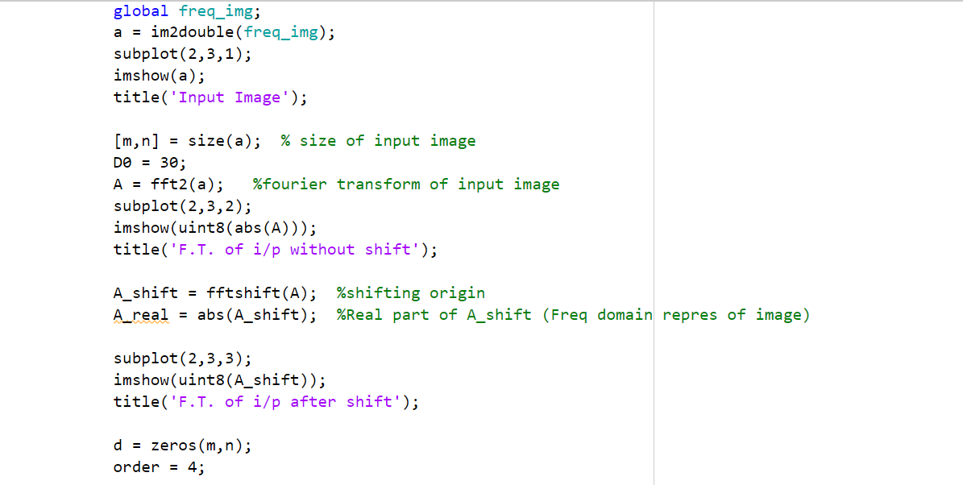

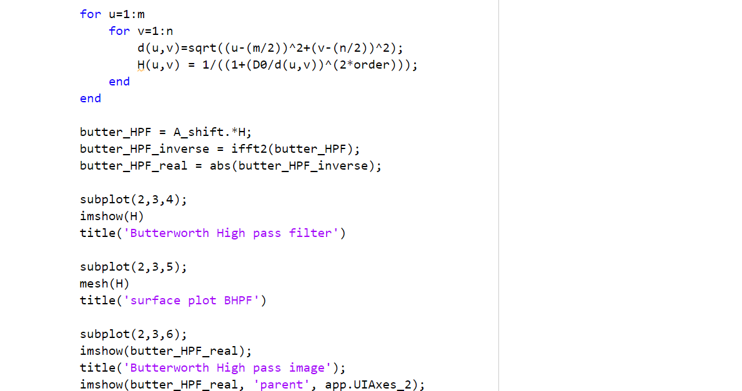

**Gaussian High Pass Filter:**

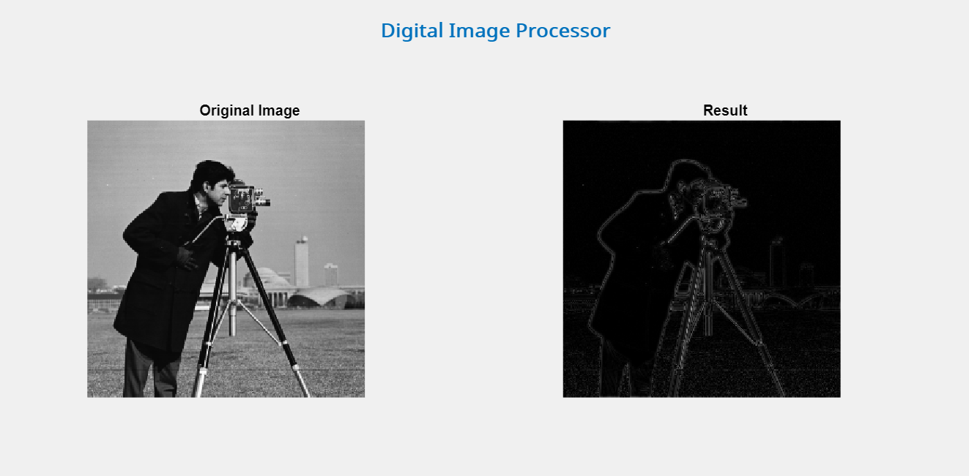

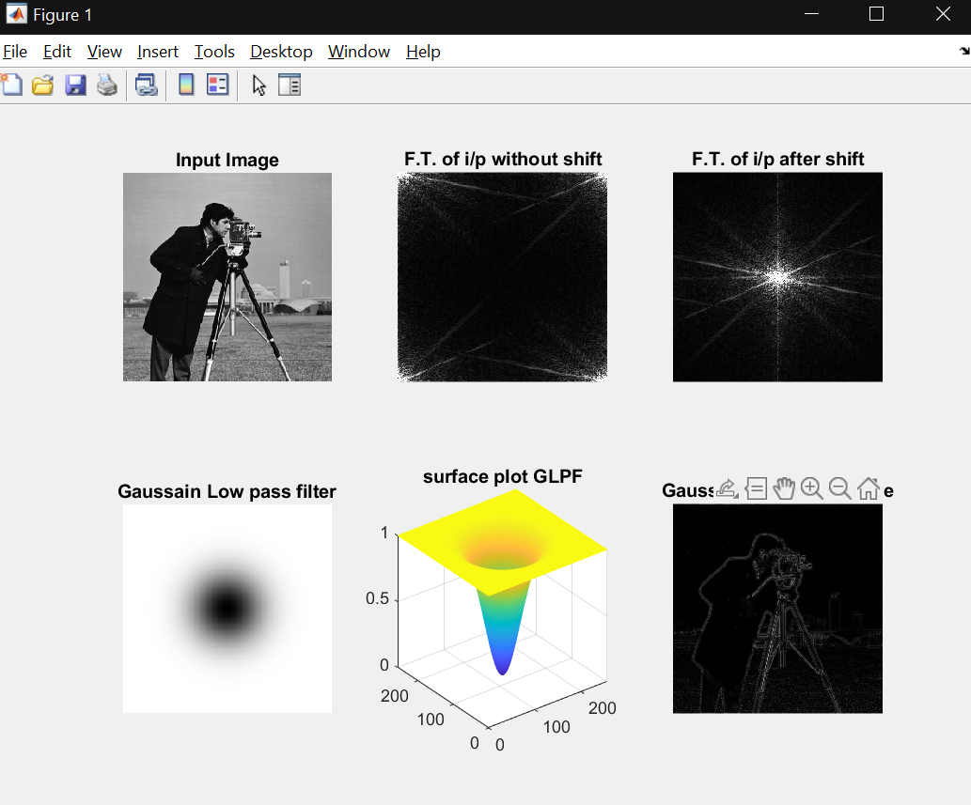

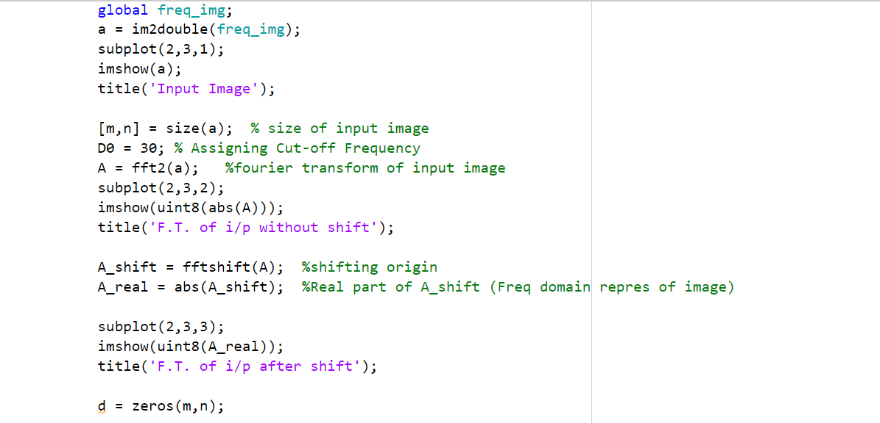Code:

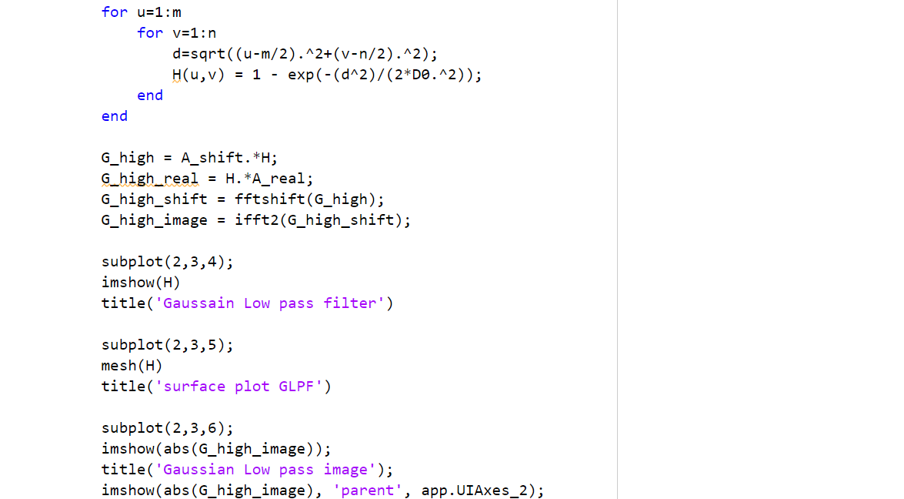

**END**